**ONLINE COURSE PORTAL FOR A UNIVERSITY**



**BTech/III Year CSE/V Semester**

**15CSE302/Database Management Systems**

**Project Review**

|  |  |
| --- | --- |
| **Rollno** | **Name** |
| **CB.EN.U4CSE18214** | **R. ASWATH SUNDAR** |
| **CB.EN.U4CSE18230** | **KAILAASH .B** |
| **CB.EN.U4CSE18202** | **S. AAKASH MUTHIAH** |
| **CB.EN.U4CSE18218** | **DHARUN VENKATESH .M** |

**Amrita School of Engineering, Coimbatore**

**Department of Computer Science and Engineering**

**2020 -2021 Odd Semester**

Table of Contents

**Chapter Title Page No.**

[Chapter 1 Introduction 3](#_Toc50366382)

[Chapter 2 Logical Database Design ER Diagram 5](#_Toc50366384)

[Chapter 3 ER to Relational Schema Mapping 10](#_Toc50366388)

[Chapter 4 User Interface Screens 11](#_Toc50366389)

[Chapter 5 Normalization 13](#_Toc52457358)

[Chapter 6 Creation of Tables 2](#_Toc52457367)5

[Chapter 7 User Interface Design 3](#_Toc52457368)9

[Chapter 8 Connectivity code 4](#_Toc52457368)5

[Chapter 9 Final UI with reports 5](#_Toc52457368)5

[References 6](#_Toc50366390)2

# 

# Chapter 1

# Introduction:

With the humongous growth of computer technology, our lives are becoming complex too. So exploiting the computer technology to solve our day to day life problem has become the most efficient solution. One of such scenarios is maintaining course portals in educational institutions. Manually keeping track of every student’s academic record in each course is far beyond human capability. Hence developing and maintaining an online course portal prove to be beneficial for students and faculties to review their works respectively, allow faculties to grade their students and upload study materials which can later be accessed by their students.

# 

# Abstract:

This project aims at creating a course portal for a campus/institution. This allows registered users of the system to join a course available on the site and access the materials published for the course. Registration to a course can be done either as a faculty or a student. When a user registers himself as a faculty, an approval request will be sent to the administrator, so that the administrator can verify the user as a faculty. The details about the course and the study materials respective to the course are uploaded by the faculties in their course portal which can later be accessed by the students from their portals. Discussion Boards are made available for both the faculties and students for each course where there can share their ideas and faculties can make announcements. Tests can be created and conducted on the portal by the faculties. There will be a grade-book section where students can take up the tests and view their scores immediately as they complete the tests. Students can express their opinion and provide feedback on the course and faculties in the course feedback section.

# 

# Chapter 2 Logical Database Design

# ER Diagram:

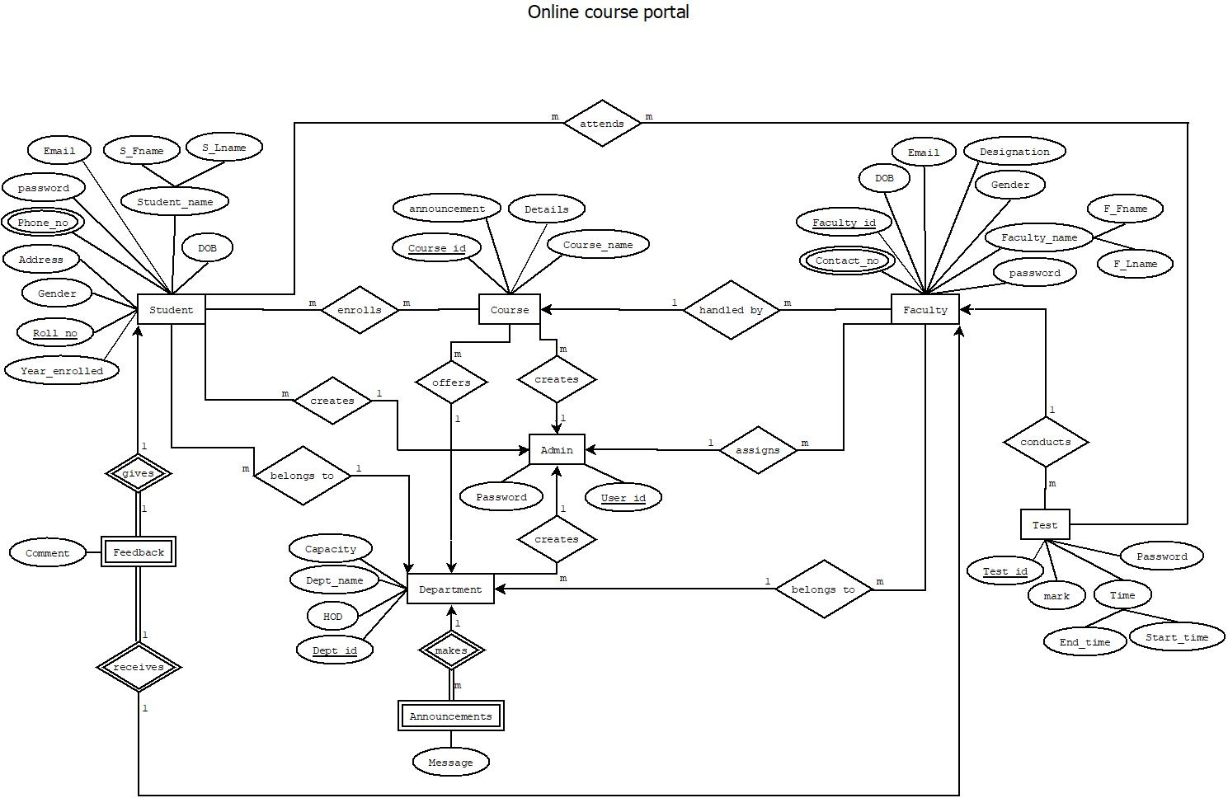

**EER DIAGRAM:**

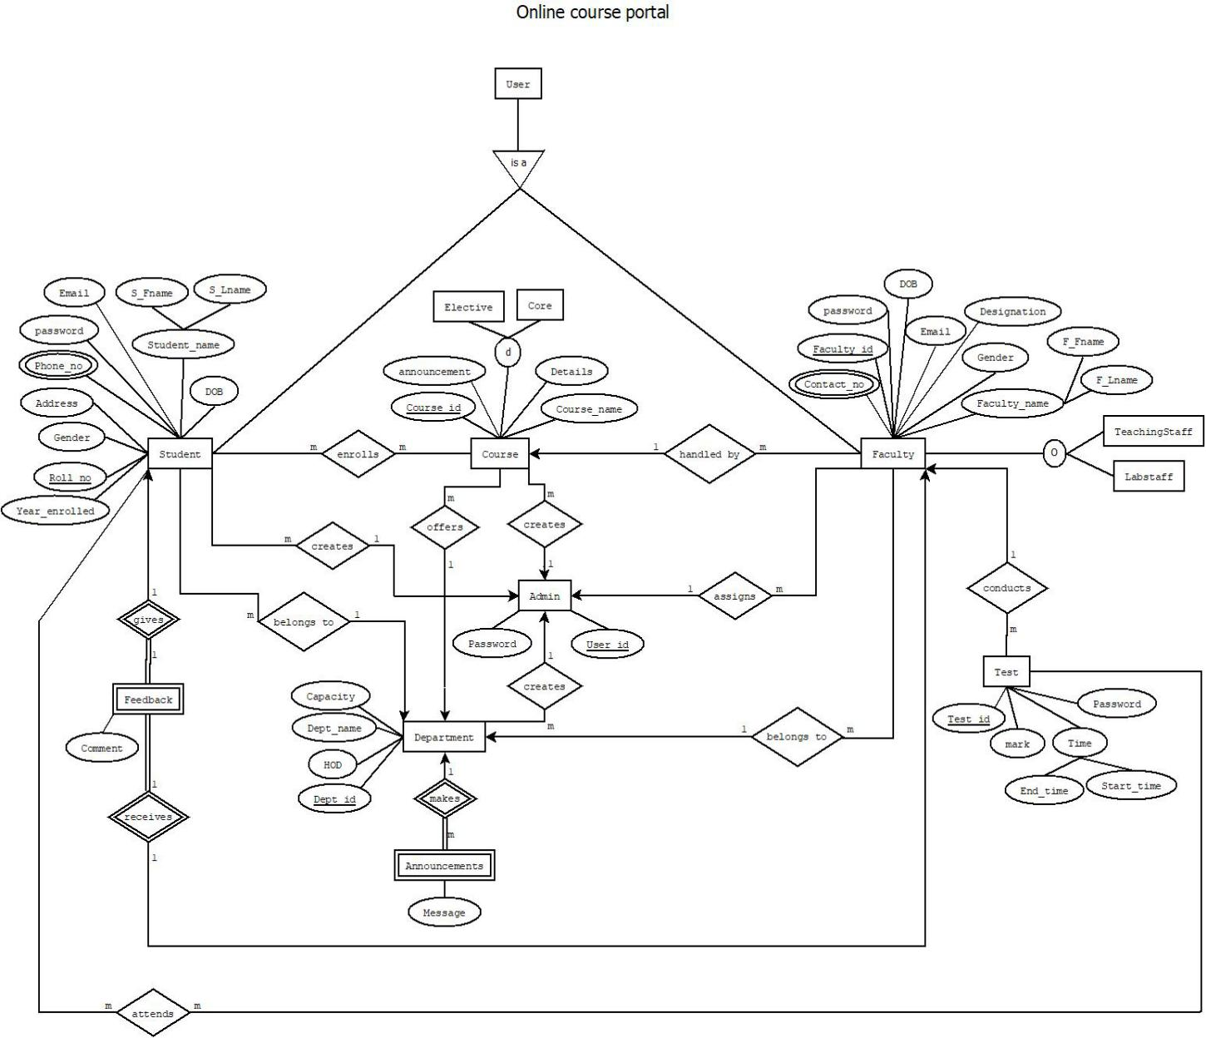

## Entities:

1. Student
2. Course
3. Faculty
4. Test
5. Announcements
6. Department
7. Feedback
8. Admin

## Attributes:

1. Student:

* Roll no
* Year\_enrolled
* Gender
* Address
* Phone\_no
* password
* Email
* Fname
* Lname
* DOB

1. Course:

* Course\_id
* Details
* Announcement
* Course\_name

1. Faculty:

* Faculty\_id
* Contact\_no
* Gender
* F\_Fname
* F\_Lname
* password
* Email
* DOB
* Designation

1. Test:

* Password
* Start\_time
* End\_time
* Mark
* Test\_id

1. Announcements:

* Message

1. Department:

* Department\_id
* Department\_name
* Capacity
* HOD

1. Feedback:

* Comment

1. Admin:

* User\_id
* Password

## 

## Relationships:

* Student *enrolls* Course
* Student *attends* Test
* Student *gives* Feedback
* Student *belongs to* Department
* Admin *creates* Student
* Admin  *creates* Course
* Admin *creates*  Department
* Admin *assigns* Faculty
* Department *makes* Announcements
* Department *offers* Course
* Faculty *belongs to* Department
* Faculty *conducts* Test
* Faculty *receives* Feedback
* Course *handled by* Faculty

# 

# Chapter 3 ER to Relational Schema Mapping

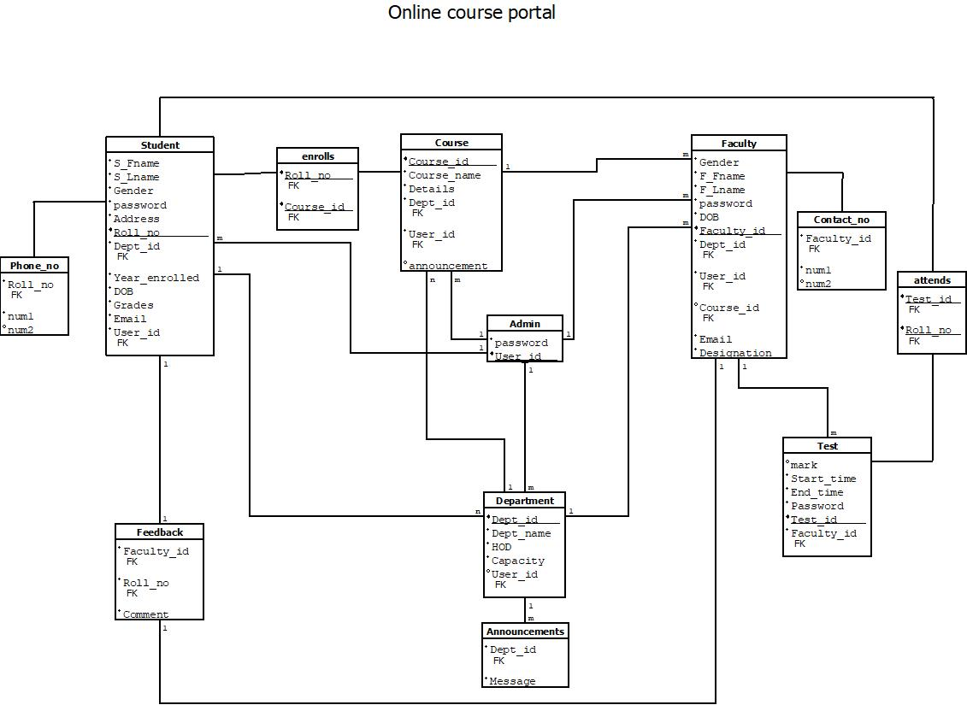

# Chapter 4 User Interface Screens

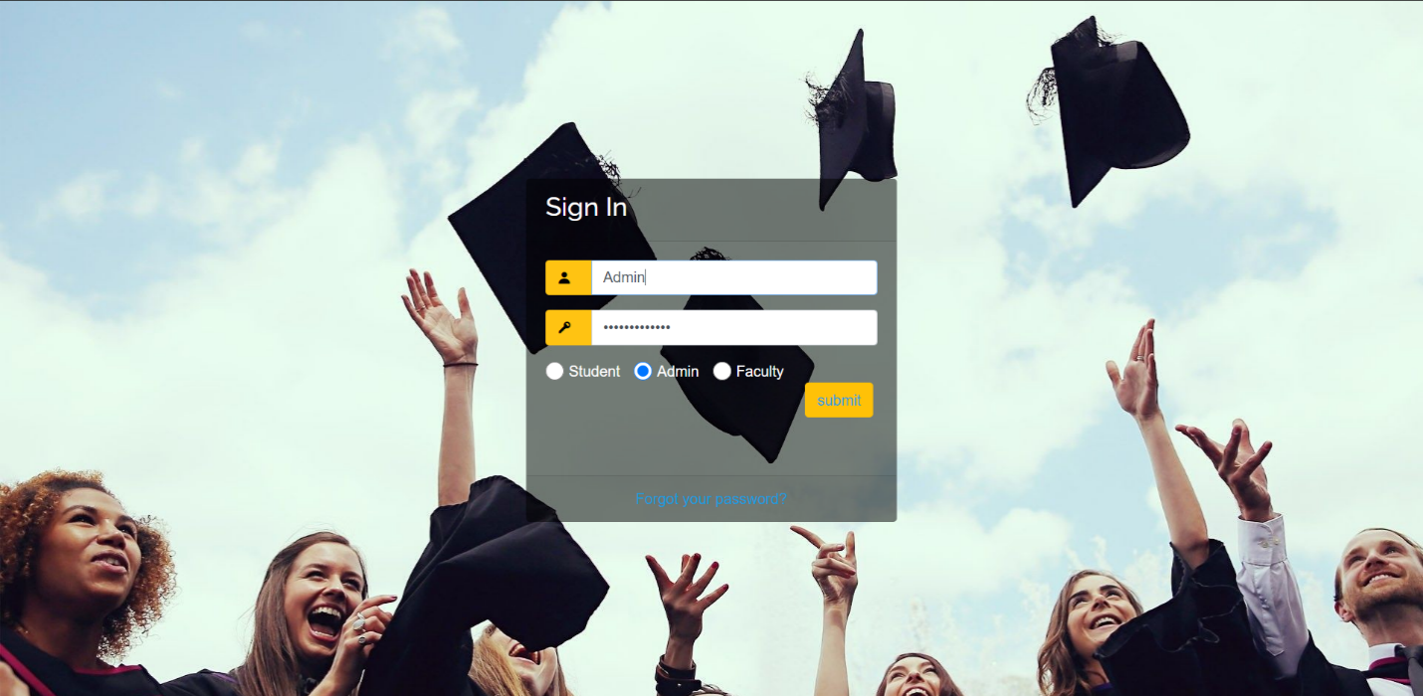

**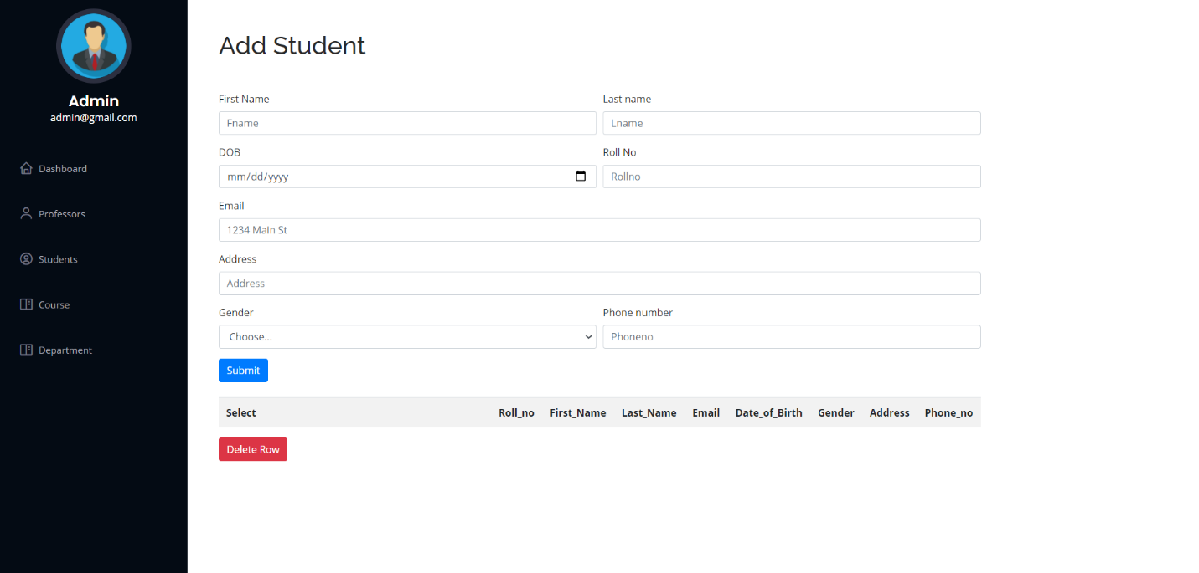**

**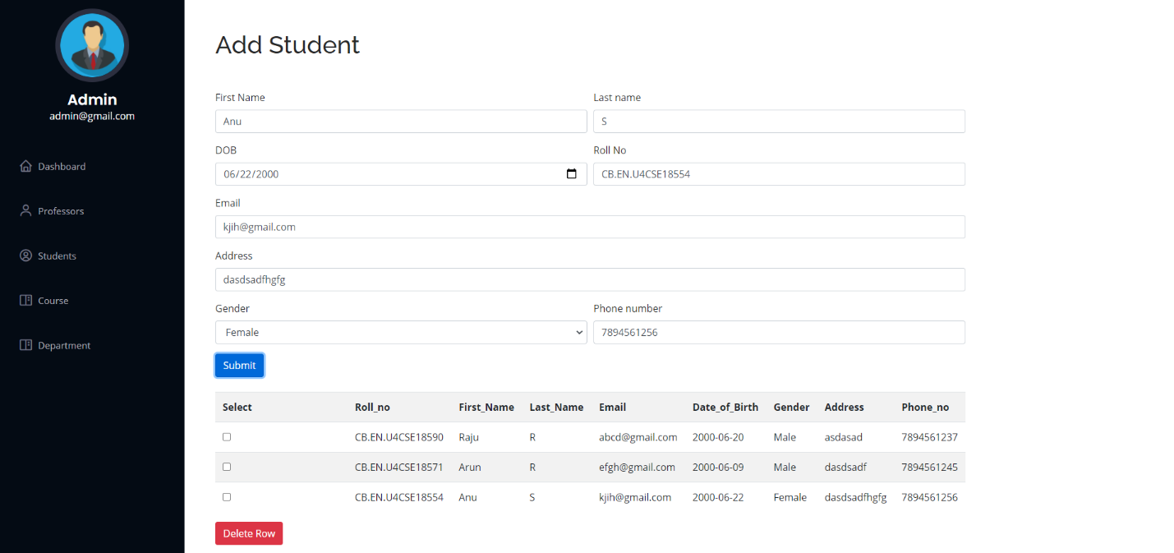**

**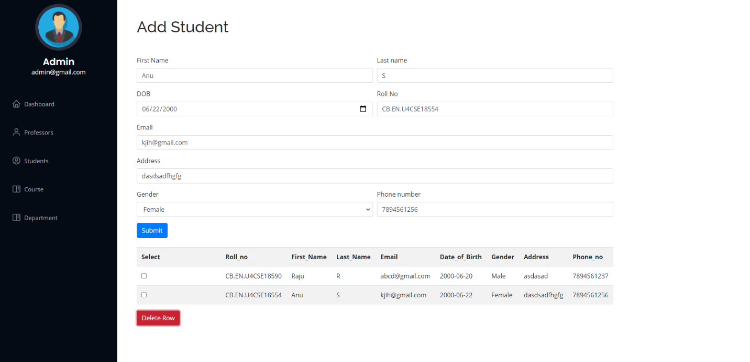**

# 

# Chapter 5 Normalization

**Schema from Relational Schema Diagram:**

* **Student**(Roll\_no,Year\_enrolled,Gender,Address,Phone\_no,password,Email,S\_Fname, S\_Lname,DOB,grades,mark\_obt)
* **Course** (Course\_id,Course\_name,Details,announcements,grades)
* **Faculty**(Faculty\_id,F\_Fname,F\_Lname,password,DOB,Gender,Phone\_no,Designation, Courses\_taught)
* **Test** (Test\_id,Start\_time,End\_time,password,mark,mark\_obt)
* **Department** (Dept\_id,Dept\_name,HOD,capacity)
* **Announcements** (Message)
* **Feedback** (Comment)

**Initial Schema**

**Online\_Course\_Portal**(Roll\_no,Course\_id,Faculty\_id,Test\_id,Dept\_id,Year\_enrolled,Courses, mark\_obt,S\_Gender,Address,S\_Phone\_no,S\_password,Email,S\_Fname,S\_Lname,S\_DOB,grades, Course\_name,Details,announcements,F\_Fname,F\_Lname,password,F\_DOB,F\_Gender, Designation,Courses\_taught,F\_Phone\_no,Start\_time,End\_time,F\_password,mark,Dept\_name, HOD, capacity, User\_id,U\_password,Message, Comment)

**Records in Initial Schema:**

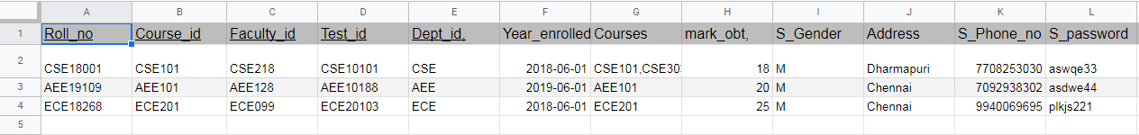

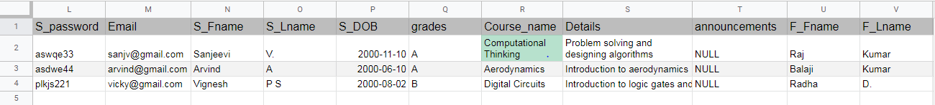

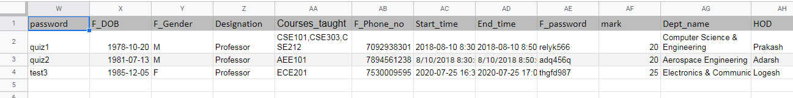

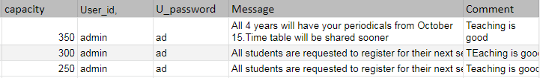

**Identifying all the Functional Dependencies:**

1. **Roll\_no**→Year\_enrolled,S\_Gender,Address,S\_Phone\_no,S\_password,Email,S\_Fname, S\_Lname,S\_DOB ,Comment,grades,mark\_obt,Courses,Dept\_id,Test\_id
2. **Course\_id**→Details,Announcement,Course\_name,grades,Dept\_id
3. **Faculty\_id**→F\_Phone\_no,F\_Gender,F\_Fname,F\_Lname,F\_password,Email,F\_DOB, Designation,Comment,Courses\_taught,Dept\_id
4. **Test\_id** →Password,Start\_time,End\_time,Mark,mark\_obt,Faculty\_id,Course\_id
5. **Dept\_id**→Department\_name,Capacity,HOD,Message

**FD Closure:**

1. **Roll\_no**→Year\_enrolled,S\_Gender,Address,S\_Phone\_no,S\_password,Email,S\_Fname, S\_Lname,S\_DOB ,Comment,grades,mark\_obt,Courses,Dept\_id,Test\_id, Department\_name,Capacity,HOD,Message,Password,Start\_time,End\_time,Mark
2. **Course\_id**→Details,Announcement,Course\_name,grades,Dept\_id,Department\_name,Capacity,HOD,Message
3. **Faculty\_id**→F\_Phone\_no,F\_Gender,F\_Fname,F\_Lname,F\_password,Email,F\_DOB, Designation,Comment,Courses\_taught,Dept\_id,Department\_name,Capacity,HOD,Message
4. **Test\_id**→Password,Start\_time,End\_time,Mark,mark\_obt,Faculty\_id,Course\_id, F\_Phone\_no,F\_Gender,F\_Fname,F\_Lname,F\_password,Email,F\_DOB, Designation,Comment,Courses\_taught,Details,Announcement,Course\_name
5. **Dept\_id**→Department\_name,Capacity,HOD,Message

**Attribute Closure:**

1. **{Roll\_no}+--Roll\_no**,Year\_enrolled,S\_Gender,Address,S\_Phone\_no,S\_password,Email, S\_Fname, S\_Lname,S\_DOB ,Comment,grades,mark\_obt,Courses,Dept\_id,Test\_id, Department\_name,Capacity,HOD,Message,Password,Start\_time,End\_time,Mark
2. **{Course\_id}+--Course\_id**,Details,Announcement,Course\_name,grades,Dept\_id, Department\_name,Capacity,HOD,Message
3. **{Faculty\_id}+--Faculty\_id**,F\_Phone\_no,F\_Gender,F\_Fname,F\_Lname,F\_password,Email, F\_DOB,Designation,Comment,Courses\_taught,Dept\_id,Department\_name,Capacity,HOD,Message
4. **{Test\_id}+--Test\_id**,Password,Start\_time,End\_time,Mark,mark\_obt,Faculty\_id, Course\_id, F\_Phone\_no,F\_Gender,F\_Fname,F\_Lname,F\_password,Email,F\_DOB, Designation,Comment,Courses\_taught,Details,Announcement,Course\_name
5. **{Dept\_id}+--Dept\_id**,Department\_name,Capacity,HOD,Message

**Canonical cover:**

Roll\_no --> Year\_enrolled

Roll\_no --> S\_Gender

Roll\_no --> Address

Roll\_no --> S\_Phone\_no

Roll\_no --> S\_password

Roll\_no --> Email

Roll\_no --> S\_Fname

Roll\_no --> S\_Lname

Roll\_no --> S\_DOB

Roll\_no --> grades

Roll\_no --> mark\_obt

Roll\_no --> Courses

Roll\_no --> Dept\_id

Roll\_no --> Test\_id

Course\_id --> Details

Course\_id --> announcements

Course\_id --> Course\_name

Course\_id--> grades

Course\_id--> Dept\_id

Faculty\_id --> F\_Fname

Faculty\_id --> F\_Lname

Faculty\_id --> F\_Gender

Faculty\_id --> F\_DOB

Faculty\_id --> F\_password

Faculty\_id --> F\_Phone\_no

Faculty\_id --> Designation

Faculty\_id --> Courses\_taught

Faculty\_id --> Email

Faculty\_id --> Dept\_id

Test\_id --> password

Test\_id --> Start\_time

Test\_id --> End\_time

Test\_id --> mark

Test\_id --> mark\_obt

Test\_id --> Course\_id

Test\_id --> Faculty\_id

Dept\_id --> Dept\_name

Dept\_id --> capacity

Dept\_id --> HOD

**Superkeys:**

Roll\_no,Course\_id,Faculty\_id,Test\_id,Dept\_id

**Anomalies:**

1. **Insertion anomalies:**When adding a course, we must assign them to a department or else use null. When adding a new department with no courses, we have to use null for the courses.There are few other insertion anomalies.
2. **Deletion anomalies:** When last record of course is deleted,we have lost the department.There are few other deletion anomalies.
3. **Update anomalies:**When a student changes his address and he is enrolled in four courses,all 4 records of that student has to be modified.There are few other update anomalies.

**Checking for 1st Normal Form:**

1. **Primary key exists**: {Roll\_no,Course\_id,Faculty\_id,Test\_id,Dept\_id} (Composite Primary Key)
2. **Some attributes are non-atomic**: {S\_Phone\_No,F\_Phone\_no,Courses,mark\_obt,

Courses\_taught,grades } are *multi-valued* attributes.

1. **There exists no repeating group of columns.**

Since non-atomic attributes exist, the relation is **not** in 1st normal form. To convert it to 1st normal form, F\_Phone\_No,S\_Phone\_no,Courses,mark\_obt,Courses\_taught,grades can be combined with the composite primary key and the multiple values can be added as separate records/tuples.

**Schema in 1st Normal Form:**

**Online\_Course\_Portal**(Roll\_no,Course\_id,Faculty\_id,Test\_id,Dept\_id,S\_Phone\_no,F\_Phone\_no,Courses\_taught,Courses,grades,mark\_obt,Year\_enrolled,S\_Gender,Address,S\_password,Email, S\_Fname,S\_Lname,S\_DOB,Course\_name,Details,announcements,F\_Fname,F\_Lname, F\_password,F\_DOB,Designation,F\_Gender,Start\_time,End\_time,password,mark,Dept\_name,HOD,capacity,Message, Comment)

**Checking for 2nd Normal Form:**

1. **It is in 1st Normal Form.**
2. **Partial Dependencies exist:**

**Roll\_no**→Year\_enrolled,S\_Gender,Address,S\_Phone\_no,S\_password,Email, S\_Fname,S\_Lname,S\_DOB,grades,mark\_obt,Courses,Dept\_id,Test\_id, Department\_name,Capacity,HOD

**Course\_id**→Details,Announcement,Course\_name,grades,Dept\_id

**Faculty\_id**→F\_Phone\_no,F\_Gender,F\_Fname,F\_Lname,F\_password,Email,F\_DOB, Designation,comment,Courses\_taught,Dept\_id,Department\_name,Capacity,HOD

**Test\_id** →Password,Start\_time,End\_time,mark,mark\_obt,Faculty\_id,Course\_id

**S\_Phone\_No , F\_Phone\_no ,grades, mark\_obt, Courses\_taught, Courses** does not determine any non-prime attribute.

Since only a part of the composite primary key determines different non-prime attributes, partial dependencies exist and therefore the relation is **not** in 2nd normal form. To convert it to 2nd normal form, the relation can be split into 9 different relations - **Student(Roll\_no), Course(Course\_id),** **Faculty(Faculty\_id),Test(Test\_id),S\_Phone\_no(S\_Phone\_no), F\_Phone\_no(F\_Phone\_no), Enrolls(Roll\_no,Course\_id), Attends(Roll\_no,Test\_id), Teaches(Faculty\_id,Course\_id)**.

We create relations **S**\_**Phone\_no,F\_Phone\_no,Enrolls,Attends,Teaches** because S\_Phone\_no and F\_Phone\_no,grades,mark\_obt,Courses\_taught,Courses are multi-valued attributes.

**Schema in 2nd Normal Form:**

* **Student**(Roll\_no,Year\_enrolled,Gender,Address,Phone\_no,password,Email,S\_Fname, S\_Lname,DOB,Dept\_id,Department\_name,Capacity,HOD)
* **Course**(Course\_id,Course\_name,Details,announcements,Dept\_id,Department\_name,Capacity, HOD)
* **Faculty**(Faculty\_id,F\_Fname,F\_Lname,password,DOB,Gender,Contact\_no,Designation, Dept\_id,Department\_name,Capacity,HOD)
* **Test** (Test\_id,Start\_time,End\_time,password,mark)
* **Phone\_no** (S\_Phone\_no,Roll\_no)
* **Contact\_no** (F\_Phone\_no,Faculty\_id)
* **Enrolls** (Roll\_no,Course\_id,grades)
* **Attends** (Roll\_no,Test\_id,mark\_obt)
* **Teaches** (Faculty\_id,Course\_id)

**Checking for 3rd Normal Form:**

* 1. **The relations are in 2nd Normal Form.**
  2. **Roll\_no-->Dept\_id**

**Course\_id-->Dept\_id**

**Faculty\_id-->Dept\_id**

Since Dept\_id is a non-prime attribute in Student,Course and Faculty and it determines HOD,Dept\_name,capacity. Transitive Dependency exist and therefore the relations are not in 3rd normal form.

To remove this transitive dependency,we create a relation Department.Now transitive dependency is eliminated and the relations are in 3rd Normal Form.

**Schema in 3rd Normal Form:**

* **Student**(Roll\_no,Year\_enrolled,Gender,Address,Phone\_no,password,Email,S\_Fname, S\_Lname,DOB)
* **Course** (Course\_id,Course\_name,Details,announcements)
* **Faculty** (Faculty\_id,F\_Fname,F\_Lname, password,DOB,Gender,Phone\_no,Designation)
* **Test** (Test\_id,Start\_time,End\_time,password,mark)
* **Department** (Dept\_id,Dept\_name,HOD,capacity)
* **Phone\_no** (S\_Phone\_no,Roll\_no)
* **Contact\_no** (F\_Phone\_no,Faculty\_id)
* **Enrolls** (Roll\_no,Course\_id,grades)
* **Attends** (Roll\_no,Test\_id,mark\_obt)
* **Teaches** (Faculty\_id,Course\_id)

**Checking if decomposition is lossless and dependencies are preserved:**

1)Create table in the form Bij

|  |  |  |  |  |  |
| --- | --- | --- | --- | --- | --- |
|  | Roll\_no | Course\_id | Faculty\_id | Test\_id | Dept\_id |
| Student | B11 | B12 | B13 | B14 | B15 |
| Course | B21 | B22 | B23 | B24 | B25 |
| Faculty | B31 | B32 | B33 | B34 | B35 |
| Test | B41 | B42 | B43 | B44 | B45 |
| Department | B51 | B52 | B53 | B54 | B55 |

2)Change to Ai where attributes are present

|  |  |  |  |  |  |
| --- | --- | --- | --- | --- | --- |
|  | Roll\_no | Course\_id | Faculty\_id | Test\_id | Dept\_id |
| Student | A1 | B12 | B13 | B14 | B15 |
| Course | B21 | A2 | B23 | B24 | B25 |
| Faculty | B31 | B32 | A3 | B34 | B35 |
| Test | B41 | B42 | B43 | A4 | B45 |
| Department | B51 | B52 | B53 | B54 | A5 |

3) Course\_id-->Dept\_id,Faculty\_id

Roll\_no-->Course\_id,Dept\_id,Test\_id

Faculty\_id-->Course\_id,Dept\_id

Test\_id-->Course\_id,Faculty\_id

|  |  |  |  |  |  |
| --- | --- | --- | --- | --- | --- |
|  | Roll\_no | Course\_id | Faculty\_id | Test\_id | Dept\_id |
| Student | A1 | A2 | A3 | A4 | A5 |
| Course | B21 | A2 | A3 | B24 | A5 |
| Faculty | B31 | A2 | A3 | B34 | A5 |
| Test | B41 | A2 | A3 | A4 | B45 |
| Department | B51 | B52 | B53 | B54 | A5 |

Since the entire student row is in the form Ai ,we can say that the decomposition is lossless.

Putting together all the dependencies from the schema,we get

**Roll\_no**→Year\_enrolled,S\_Gender,Address,S\_Phone\_no,S\_password,Email,S\_Fname, S\_Lname,S\_DOB ,Comment,grades,mark\_obt,Courses,Dept\_id,Test\_id

**Course\_id**→Details,Announcement,Course\_name,grades,Dept\_id

**Faculty\_id**→F\_Phone\_no,F\_Gender,F\_Fname,F\_Lname,F\_password,Email,F\_DOB, Designation,Comment,Courses\_taught,Dept\_id

**Test\_id** →Password,Start\_time,End\_time,Mark,mark\_obt,Faculty\_id,Course\_id

**Dept\_id**→Department\_name,Capacity,HOD,Message

Which is the same set of FDs as seen in the original schema.Therefore we can say that the decompostion is dependency preserving.

**Checking for BCNF:**

**1)The relation are in 3rd Normal Form.**

**2) All determinants are super keys.**

Since no non-key attributes are determinants and the relations are in 3rd Normal Form,the relations are already in BCNF.There is no need for any further normalization.The schema is same as 3rd Normal Form.

**Final Schema:**

* **Student**(Roll\_no,Year\_enrolled,Gender,Address,Phone\_no,password,Email,S\_Fname, S\_Lname,DOB)
* **Course** (Course\_id,Course\_name,Details,announcements)
* **Faculty** (Faculty\_id,F\_Fname,F\_Lname, password,DOB,Gender,Phone\_no,Designation)
* **Test** (Test\_id,Start\_time,End\_time,password,mark)
* **Department** (Dept\_id,Dept\_name,HOD,capacity)
* **Phone\_no** (S\_Phone\_no,Roll\_no)
* **Contact\_no** (F\_Phone\_no,Faculty\_id)
* **Enrolls** (Roll\_no,Course\_id,grades)
* **Attends** (Roll\_no,Test\_id,mark\_obt)
* **Teaches** (Faculty\_id,Course\_id)

**Dependency diagram:**

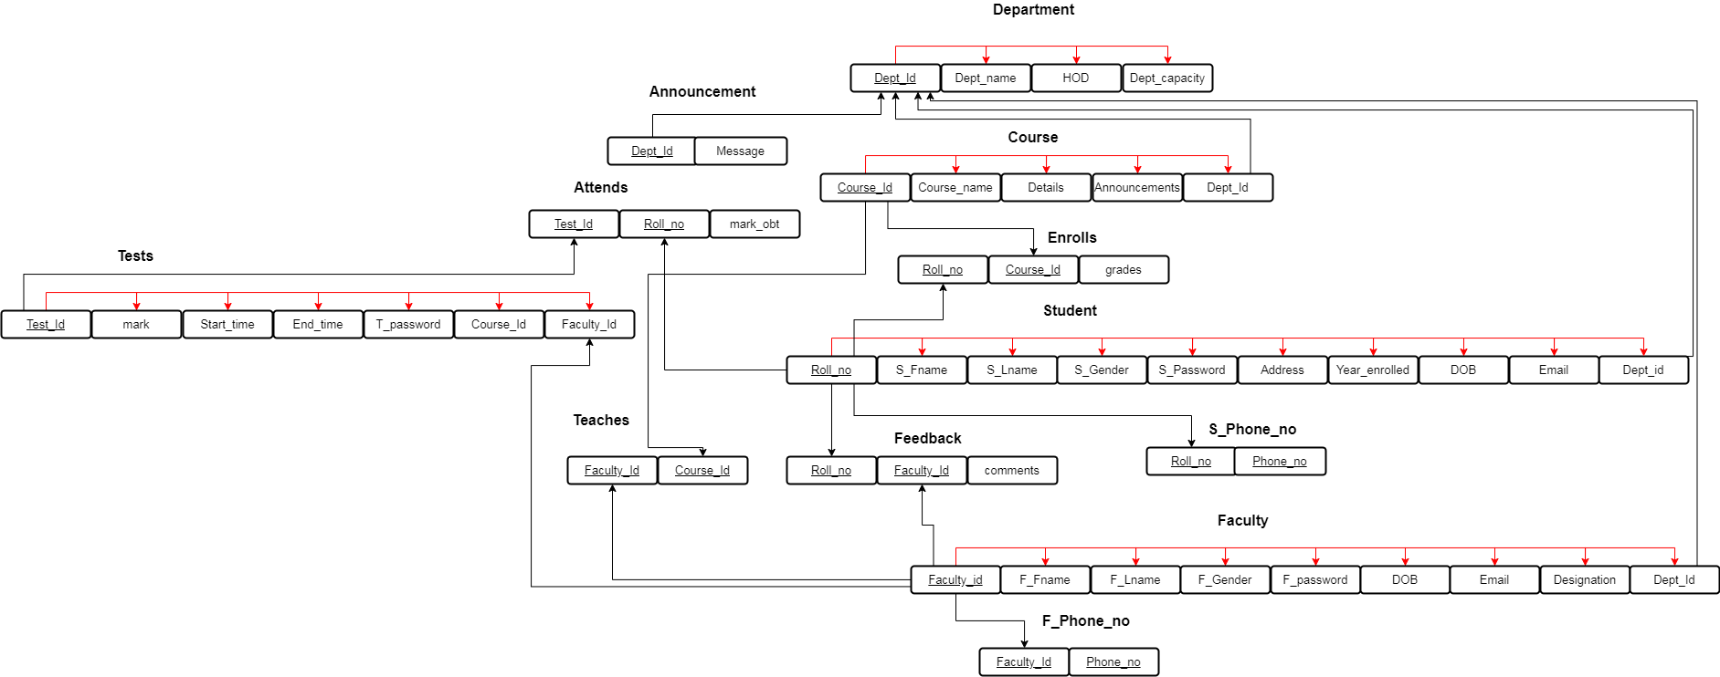

# Chapter 6 Creation of Tables

1. **Include the create command for ALL THE TABLES, sample insert commands.**

create table Department

(

Dept\_id varchar2(10) not null,

Dept\_name varchar2(45) not null,

HOD varchar2(25) not null,

Dept\_capacity number(4,0) not null,

constraint dept\_pk primary key(Dept\_id)

);

create table Course

(

Course\_id varchar2(10) not null,

Course\_name varchar2(40) not null,

Details varchar2(75) not null,

Announcements varchar2(75),

Dept\_id varchar2(10),

constraint course\_pk primary key(Course\_id),

constraint course\_fk foreign key(Dept\_id) references Department(Dept\_id)

);

create table Faculty

(

Faculty\_id varchar2(10) not null,

F\_Fname varchar2(15) not null,

F\_Lname varchar2(15) not null,

Gender char(1) not null,

DOB date not null,

F\_password varchar2(15) not null,

Designation varchar2(15),

Email varchar2(25) not null,

Dept\_id varchar2(10),

constraint faculty\_pk primary key(Faculty\_id),

constraint faculty\_fk foreign key(Dept\_id) references Department(Dept\_id)

);

create table Student

(

Roll\_no varchar2(10) not null,

S\_Fname varchar2(15) not null,

S\_Lname varchar2(15) not null,

Gender char(1) not null,

DOB date not null,

Year\_enrolled date not null,

S\_password varchar2(15) not null,

Email varchar2(25) not null,

Address varchar2(40),

Dept\_id varchar2(10),

constraint student\_pk primary key(Roll\_no),

constraint student\_fk foreign key(Dept\_id) references Department(Dept\_id)

);

create table Tests

(

Test\_id varchar2(10) not null,

Start\_time timestamp not null,

End\_time timestamp not null,

T\_password varchar2(15),

mark number(3,0) not null,

Faculty\_id varchar2(10),

Course\_id varchar2(10),

constraint test\_pk primary key(Test\_id),

constraint test\_fk1 foreign key(Faculty\_id) references Faculty(Faculty\_id),

constraint test\_fk2 foreign key(Course\_id) references Course(Course\_id)

);

create table S\_Phone\_no

(

Roll\_no varchar2(10) not null,

Phone\_no varchar2(10) not null,

constraint phone\_pk primary key(Roll\_no,Phone\_no),

constraint phone\_fk foreign key(Roll\_no) references Student(Roll\_no)

);

create table F\_Phone\_no

(

Faculty\_id varchar2(10) not null,

Phone\_no varchar2(10) not null,

constraint F\_phone\_pk primary key(Faculty\_id,Phone\_no),

constraint F\_phone\_fk foreign key(Faculty\_id) references Faculty(Faculty\_id)

);

create table Announcement

(

Dept\_id varchar2(10),

Message varchar2(100),

constraint announce\_pk primary key(Dept\_id,Message),

constraint announce\_fk foreign key(Dept\_id) references Department(Dept\_id)

);

create table Feedback

(

Roll\_no varchar2(10),

Faculty\_id varchar2(10),

comments varchar2(75),

constraint feedback\_pk primary key(Roll\_no,Faculty\_id,comments),

constraint feedback\_fk1 foreign key(Roll\_no) references Student(Roll\_no),

constraint feedback\_fk2 foreign key(Faculty\_id) references Faculty(Faculty\_id)

);

create table Enrolls

(

Roll\_no varchar2(10),

Course\_id varchar2(10),

grades varchar2(2),

constraint enrolls\_pk primary key(Roll\_no,Course\_id),

constraint enrolls\_fk1 foreign key(Roll\_no) references Student(Roll\_no),

constraint enrolls\_fk2 foreign key(Course\_id) references Course(Course\_id)

);

create table Attends

(

Roll\_no varchar2(10),

Test\_id varchar2(10),

mark\_obt number(3,0),

constraint attends\_pk primary key(Roll\_no,Test\_id),

constraint attends\_fk1 foreign key(Roll\_no) references Student(Roll\_no),

constraint attends\_fk2 foreign key(Test\_id) references Tests(Test\_id)

);

create table Teaches

(

Faculty\_id varchar2(10),

Course\_id varchar2(10),

constraint teaches\_pk primary key(Faculty\_id,Course\_id),

constraint teaches\_fk1 foreign key(Faculty\_id) references Faculty(Faculty\_id),

constraint teaches\_fk2 foreign key(Course\_id) references Course(Course\_id)

);

1. **Minimum 10 meaningful records to be inserted.**

**Department:**

insert into Department values('CSE','Computer Science & Engineering','Prakash',350);

insert into Department values('EEE','Electrical & Electronics Engineering','Jenardhanan',150);

insert into Department values('ECE','Electronics & Communication Engineering','Logesh',250);

insert into Department values('MEE','Mechanical Engineering','Anirudh',200);

insert into Department values('CIV','Civil Engineering','Surendar',150);

insert into Department values('EIE','Electronics & Instrumentation Engineering','Martha',150);

insert into Department values('AEE','Aerospace Engineering','Rashmi',350);

insert into Department values('MAT','Mathematics','Anand',200);

insert into Department values('PHY','Physics','Vijay',150);

insert into Department values('CHE','Chemistry','Boobalan',150);

**Course:**

insert into Course values('CSE101','Computational Thinking','Problem solving and designing algorithms',NULL,'CSE');

insert into Course values('CSE303','Theory of Computation','Basics of automata and construction of automata',NULL,'CSE');

insert into Course values('CSE212','Embedded Systems','Introduction to microcontrollers and microprocessors',NULL,'CSE');

insert into Course values('MEE101','Engineering Drawing','Introduction to engineering drawing standards and their usage',NULL,'MEE');

insert into Course values('EEE111','Fundamentals of EEE','Introduction to electric circuits and problem solving',NULL,'EEE');

insert into Course values('ECE201','Digital Circuits','Introduction to logic gates and combinational circuits',NULL,'ECE');

insert into Course values('CIV101','Statics and Dynamics','Introduction to concepts of force,moment and mechanical equilibrium ',NULL,'CIV');

insert into Course values('AEE101','Aerodynamics','Introduction to aerodynamics',NULL,'AEE');

insert into Course values('MAT101','Matrix Algebra','System of Linear equations and Linear independence',NULL,'MAT');

insert into Course values('CHE101','Photochemistry','Laws of photochemistry and photochemical processes',NULL,'CHE');

**Faculty:**

insert into Faculty values('CSE218','Raj','Kumar','M',date '1978-10- 20','relyk566','Professor','raj75@gmail.com','CSE');

insert into Faculty values('MEE110','Saravana','Kumar','M',date '1980-11- 26','poise123','Asst.Professor','saro.k@gmail.com','MEE');

insert into Faculty values('EEE018','Uma','M.','F',date '1980-05- 10','abcde987','Professor','uma.m80@gmail.com','EEE');

insert into Faculty values('ECE099','Radha','D.','F',date '1985-12- 05','thgfd987','Professor','dradha@gmail.com','ECE');

insert into Faculty values('CIV218','Prakash','Raj','M',date '1967-02- 16','asdfc453','Asst.Professor','raj.praks@gmail.com','CIV');

insert into Faculty values('EIE180','Rakesh','Sharma','M',date '1978-09- 09','rrrty325','Professor','rakesh123@gmail.com','EIE');

insert into Faculty values('AEE010','Balaji','K.','M',date '1981-07-13','uhkkj768','Lab faculty','balag@gmail.com','AEE');

insert into Faculty values('MAT131','Ramanan','Nair','M',date '1979-05- 06','zxcbv436','Professor','ram.nair@gmail.com','MAT');

insert into Faculty values('CHE001','Kavitha','E.','F',date '1986-01- 01','tenzs991','Asst.Professor','kavithaaa@gmail.com','CHE');

insert into Faculty values('PHY218','Unnikrishnan','S.','M',date '1968-04- 29','aceuu660','Asst.Professor','u.krishnan@gmail.com','PHY');

**Student:**

insert into Student values('CSE18001','Sanjeevi','V.','M',date '2000-11-10',date '2018-06- 01','aswqe331','sanjv@gmail.com','Dharmapuri','CSE');

insert into Student values('MEE19142','Sai','Brahadeesh','M',date '2001-02-08',date '2019-06-01','dhbdu001','saib2001@gmail.com','Chennai','MEE');

insert into Student values('EEE18019','Ganesh','U.','M',date '2000-10-26',date '2018-06- 01','dsdad665','u.ganesh@gmail.com','Bangalore','EEE');

insert into Student values('ECE18268','Vignesh','P S','M',date '2000-08-02',date '2018- 06-01','plkjs221','vicky@gmail.com','Chennai','ECE');

insert into Student values('CIV19109','Arun','Kumar','M',date '2000-04-04',date '2019- 06-01','tyuas443','arunjak@gmail.com','Vadalur','CIV');

insert into Student values('EIE18031','Karthic','Narayana','M',date '2001-03-21',date '2018-06-01','rfghe579','karthicn@gmail.com','Salem','EIE');

insert into Student values('AEE19109','Arvind','A.','M',date '2000-03-12',date '2019-06- 01','azlmj486','arvindd2000@gmail.com','Chennai','AEE');

insert into Student values('MAT18128','Gowri','Shankar','M',date '2000-07-15',date '2018-06-01','khjfu542','gowriii@gmail.com','Chennnai','MAT');

insert into Student values('CHE18020','Gautam','R.','M',date '2001-02-18',date '2018-06- 01','lsmass200','gautamr2001@gmail.com','Chennai','CHE');

insert into Student values('PHY19145','Ramanish','Shankar','M',date '20001-12-28',date '2019-06-01','xvyte409','ram.manish@gmail.com','Rajapalayam','PHY');

**Tests:**

insert into Tests values('CSE10101',timestamp '2018-08-10 08:30:00',timestamp '2018- 08-10 08:50:00','quiz1',20,'CSE218','CSE101');

insert into Tests values('CSE30302',timestamp '2020-07-11 09:00:00',timestamp '2020- 07-11 09:30:00','quiz2',15,'CSE218','CSE303');

insert into Tests values('MEE10105',timestamp '2019-08-10 10:30:00',timestamp '2019- 08-10 11:00:00','quiz123',20,'MEE110','MEE101');

insert into Tests values('ECE20103',timestamp '2020-07-25 16:30:00',timestamp '2020- 07-25 17:00:00','test3',30,'ECE099','ECE201');

insert into Tests values('EEE11103',timestamp '2019-01-14 14:00:00',timestamp '2019- 01-14 14:15:00','quiz3',15,'EEE018','EEE111');

**S\_Phone\_no:**

insert into S\_Phone\_no values('CSE18001','7708253030');

insert into S\_Phone\_no values('MEE19142','8838671670');

insert into S\_Phone\_no values('EEE18019','8056350652');

insert into S\_Phone\_no values('ECE18268','9940069695');

insert into S\_Phone\_no values('CIV19109','6382108136');

insert into S\_Phone\_no values('EIE18031','9489021611');

insert into S\_Phone\_no values('AEE19109','9940413984');

insert into S\_Phone\_no values('MAT18128','9789047248');

insert into S\_Phone\_no values('CHE18020','6379087509');

insert into S\_Phone\_no values('MEE19142','9176520780');

**F\_Phone\_no:**

insert into F\_Phone\_no values('CSE218','7092938301');

insert into F\_Phone\_no values('MEE110','9486090160');

insert into F\_Phone\_no values('EEE018','9486329395');

insert into F\_Phone\_no values('ECE099','7530009595');

insert into F\_Phone\_no values('CIV218','8754220465');

insert into F\_Phone\_no values('EIE180','8903873941');

insert into F\_Phone\_no values('AEE010','9487130698');

insert into F\_Phone\_no values('MAT131','9025108439');

insert into F\_Phone\_no values('CHE001','7893563777');

insert into F\_Phone\_no values('CSE218','6379497383');

**Announcement:**

insert into Announcement values('CSE','All 4 years will have your periodicals from October 15.Time table will be shared sooner');

insert into Announcement values('CSE','There will be a webinar to give you guys an insight into placements');

insert into Announcement values('MEE','Exam date has been postponed.New date will be announced soon');

insert into Announcement values('ECE','All students are requested to register for their next sem courses');

insert into Announcement values('EEE','Exam date has been postponed.New date will be announced soon');

insert into Announcement values('CHE','Exam date has been postponed.New date will be announced soon');

insert into Announcement values('PHY','Lab classes will be a free hour next week');

insert into Announcement values('AEE','All students are requested to register for their next sem courses');

insert into Announcement values('EIE','Due date for project submission has been extended');

insert into Announcement values('MAT','No classes will take place tomorrow');

**Feedback:**

insert into Feedback values('CSE18001','CSE218','Teaching is good');

insert into Feedback values('MEE19142','MEE110','More emphasis can be given on problem solving');

insert into Feedback values('EEE18019','EEE018','Resources are not updated');

insert into Feedback values('ECE18268','ECE099','Teaching is good');

insert into Feedback values('CIV19109','CIV218','Quiz can be conducted dduring class hours');

insert into Feedback values('EIE18031','EIE180','Theory sessions are too fast');

insert into Feedback values('AEE19109','AEE010','Teaching is good');

insert into Feedback values('MAT18128','MAT131','It would be nice if the main focus is on problem solving');

insert into Feedback values('CHE18020','CHE001','Lab evaluation time is too short');

insert into Feedback values('PHY19145','PHY218','No problems');

**Enrolls:**

insert into enrolls values('CSE18001','CSE101','A');

insert into enrolls values('MEE19142','MEE101','B');

insert into enrolls values('CSE18001','CSE212','O');

insert into enrolls values('EEE18019','EEE111','A');

insert into enrolls values('ECE18268','ECE201','B');

insert into enrolls values('CIV19109','CIV101','O');

insert into enrolls values('AEE19109','AEE101','C');

insert into enrolls values('MAT18128','MAT101','A');

insert into enrolls values('CHE18020','CHE101','B');

insert into enrolls values('CSE18001','CSE303','A+');

**Teaches:**

insert into Teaches values('CSE218','CSE101');

insert into Teaches values('CSE218','CSE212');

insert into Teaches values('CSE218','CSE303');

insert into Teaches values('MEE110','MEE101');

insert into Teaches values('EEE018','EEE111');

insert into Teaches values('ECE099','ECE201');

insert into Teaches values('CIV218','CIV101');

insert into Teaches values('AEE010','AEE101');

insert into Teaches values('MAT131','MAT101');

insert into Teaches values('CHE001','CHE101');

**Attends:**

insert into attends values('CSE18001','CSE10101','18');

insert into attends values('MEE19142','MEE10105','20');

insert into attends values('EEE18019','EEE11103','12');

insert into attends values('ECE18268','ECE20103','25');

insert into attends values('CSE18001','CSE30302','8');

1. **Data from all the tables.**

# IMG_256

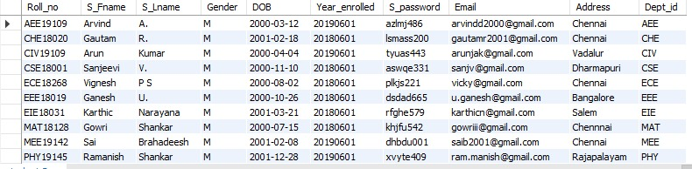

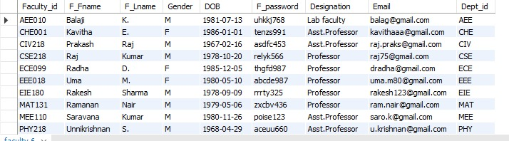

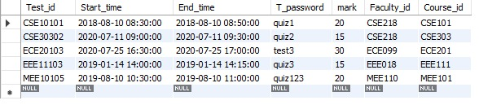

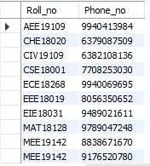

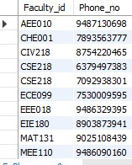

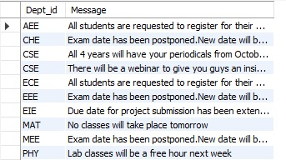

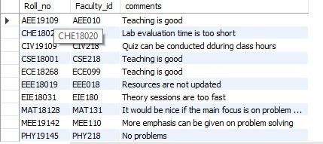

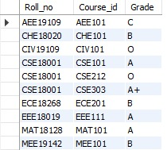

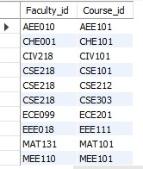

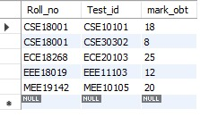

# IMG_256

# 

# Chapter 7 User Interface Design

**UI screens for data entry into all the tables.**

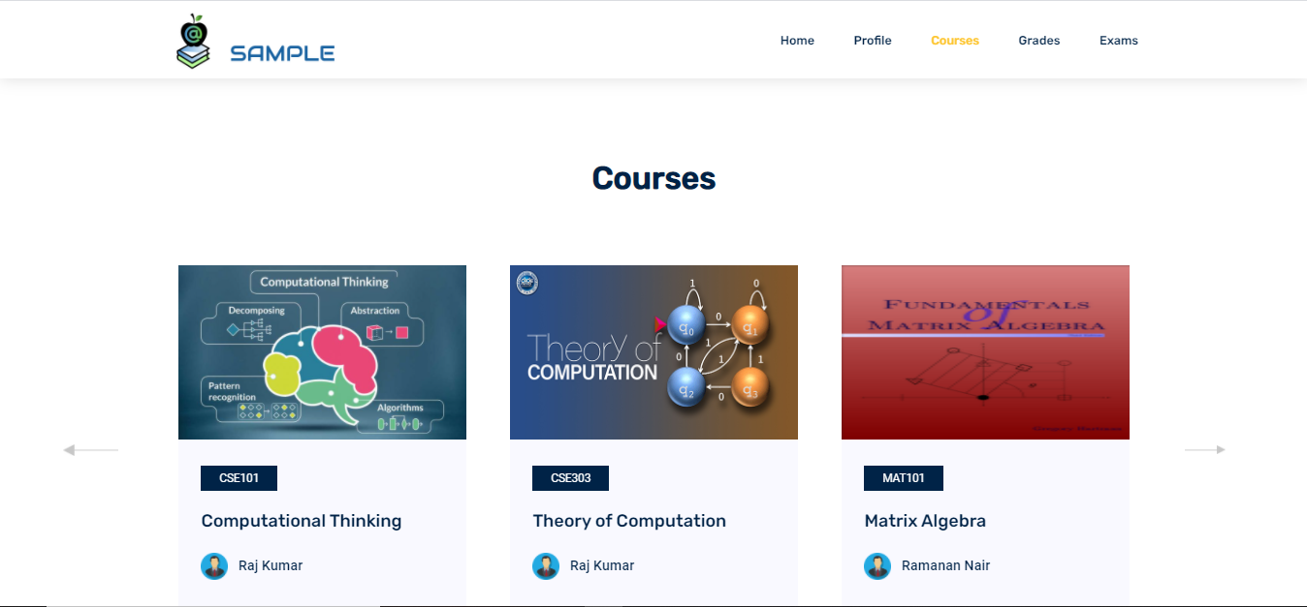

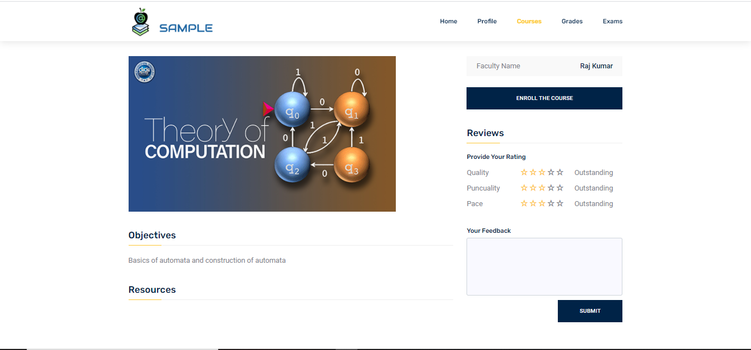

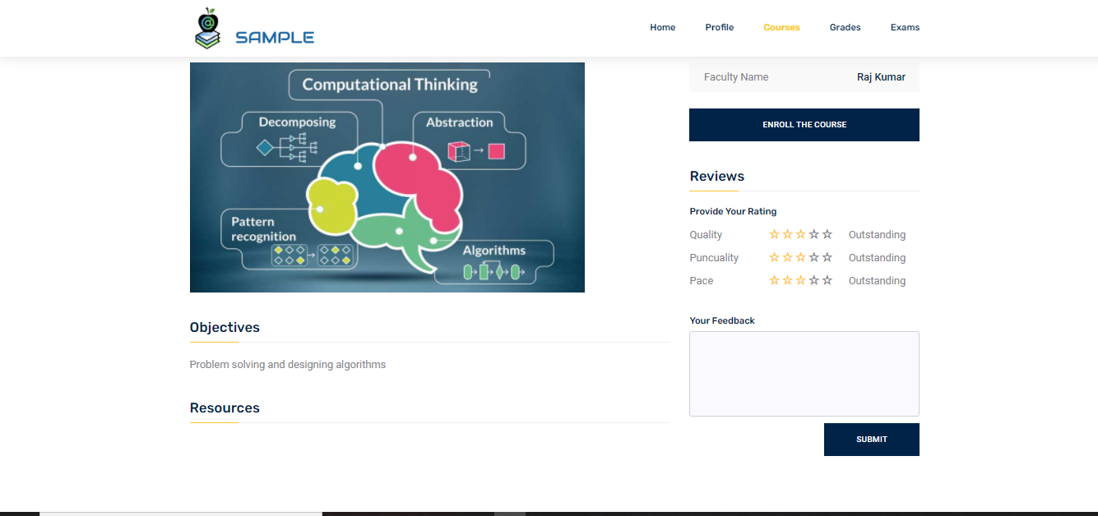

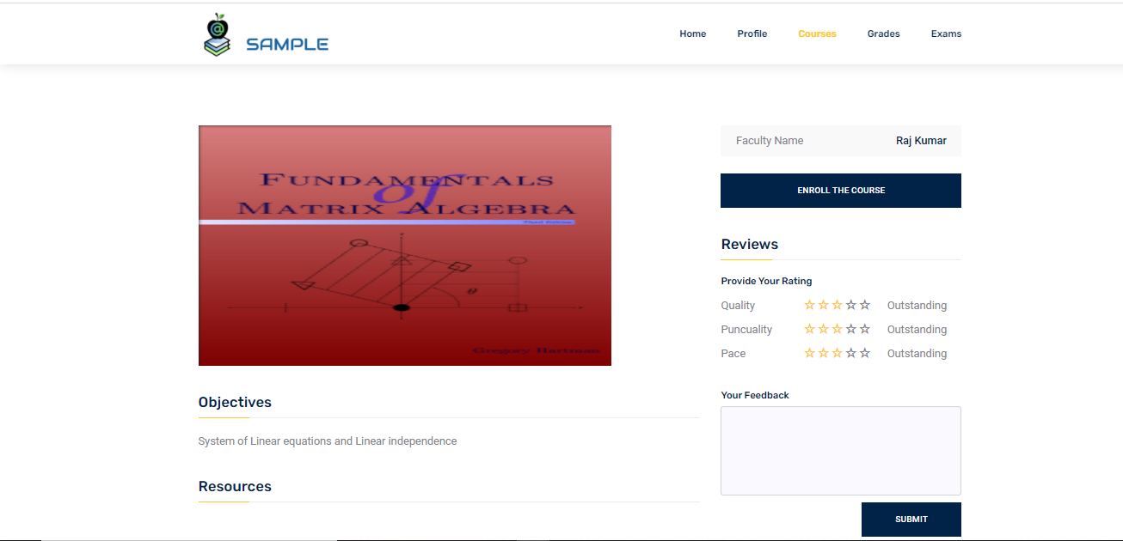

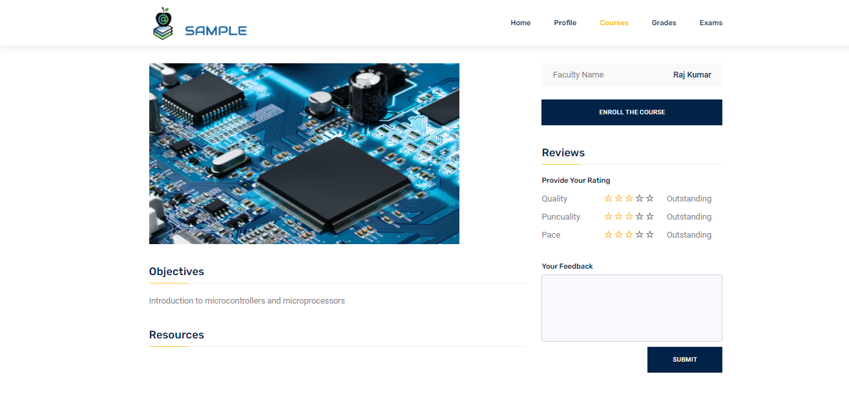

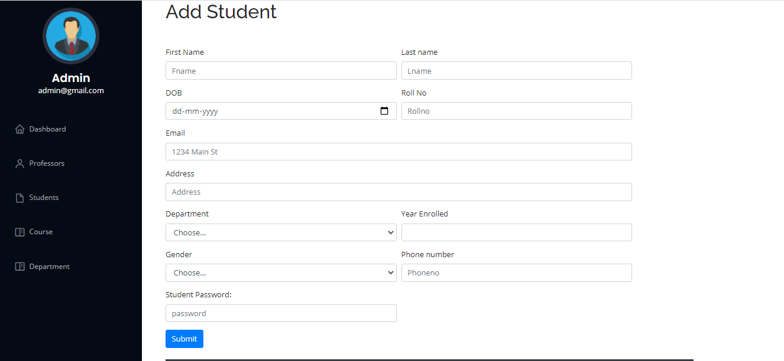

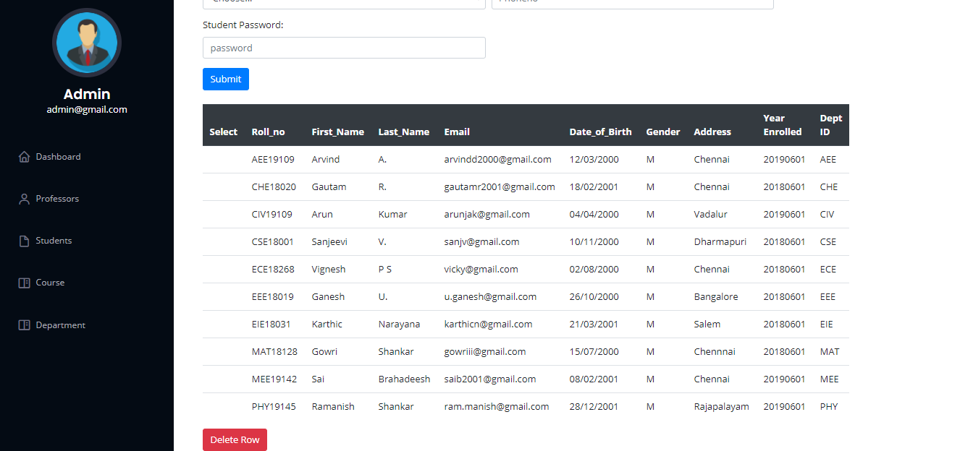

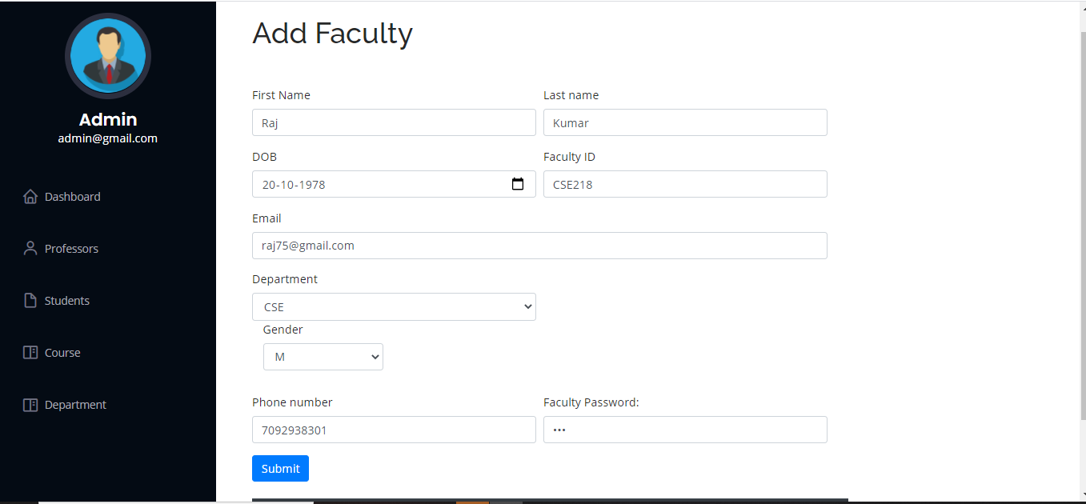

# IMG_256

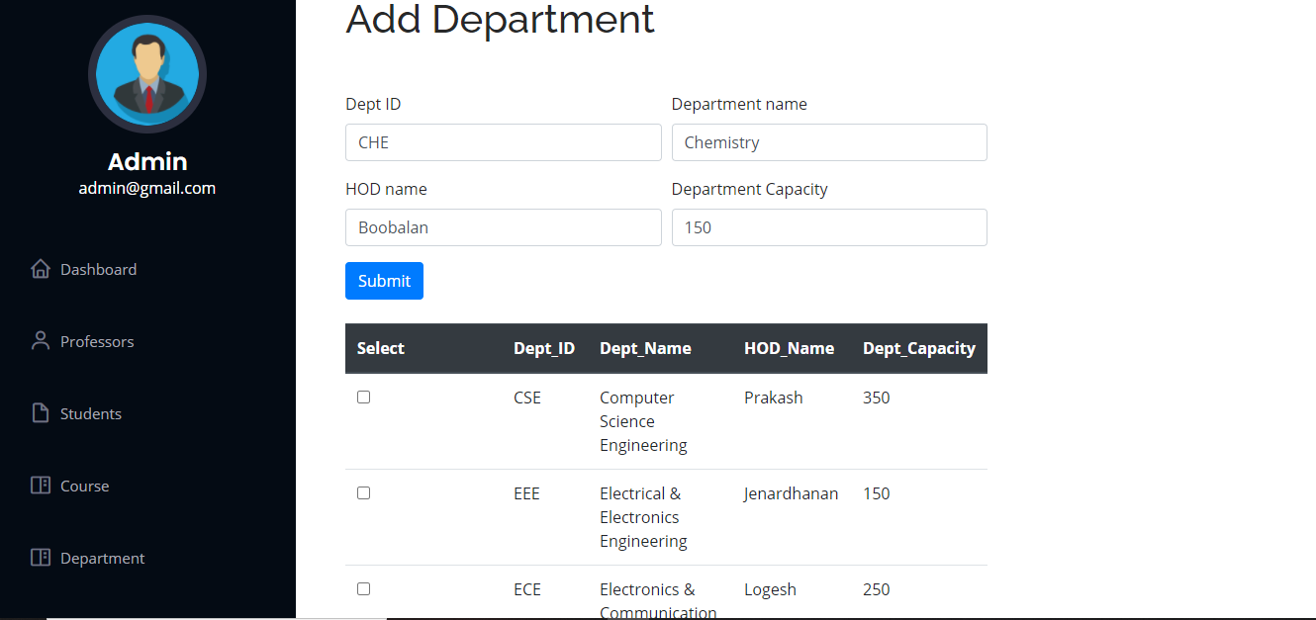

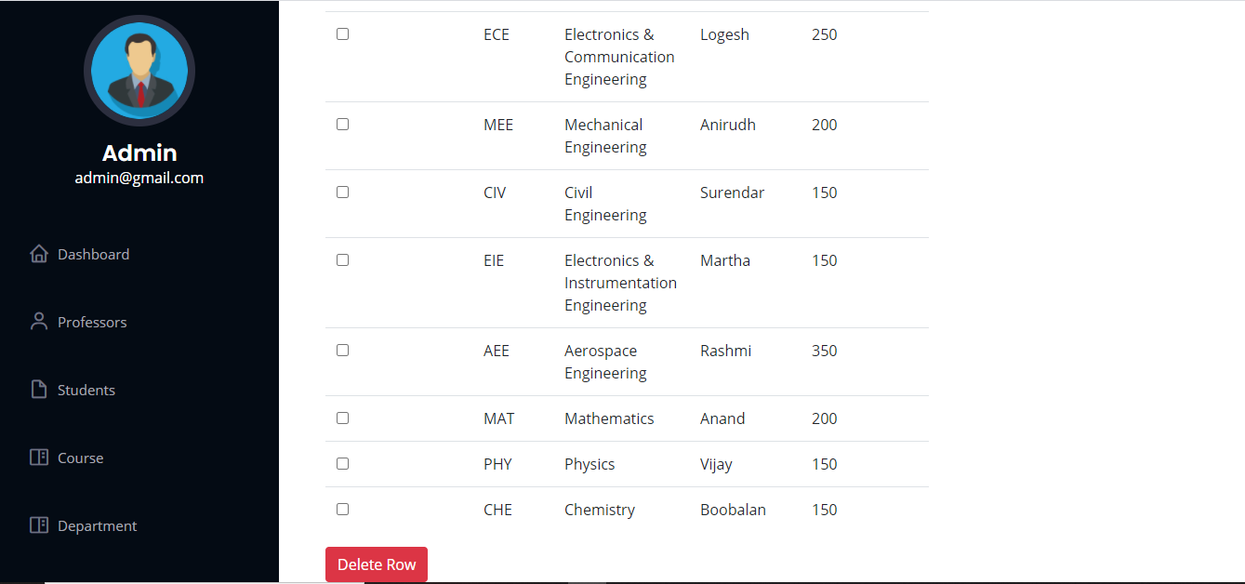

# Chapter 8 Connectivity Code

# IMG_256

# IMG_256

# IMG_256

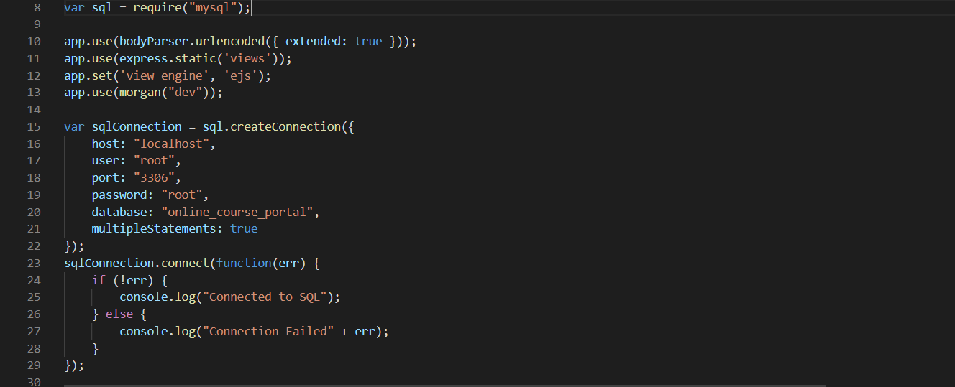

# IMG_256

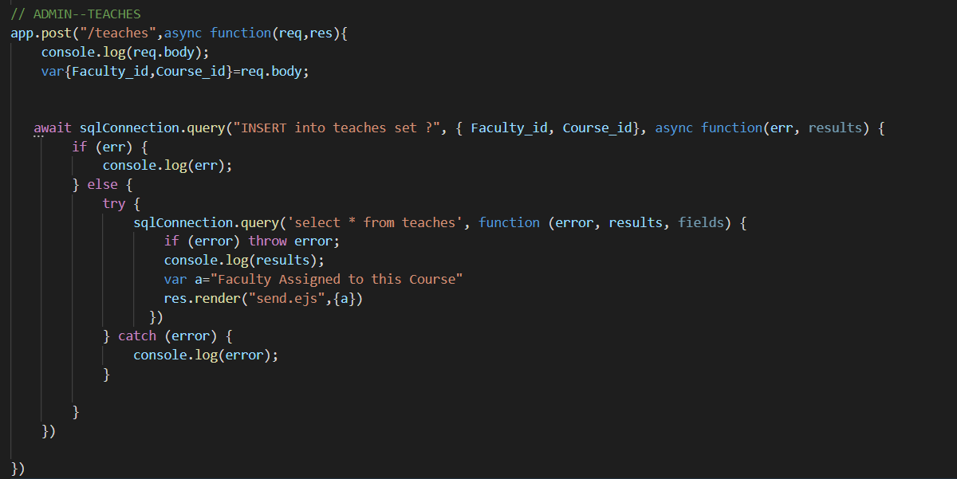

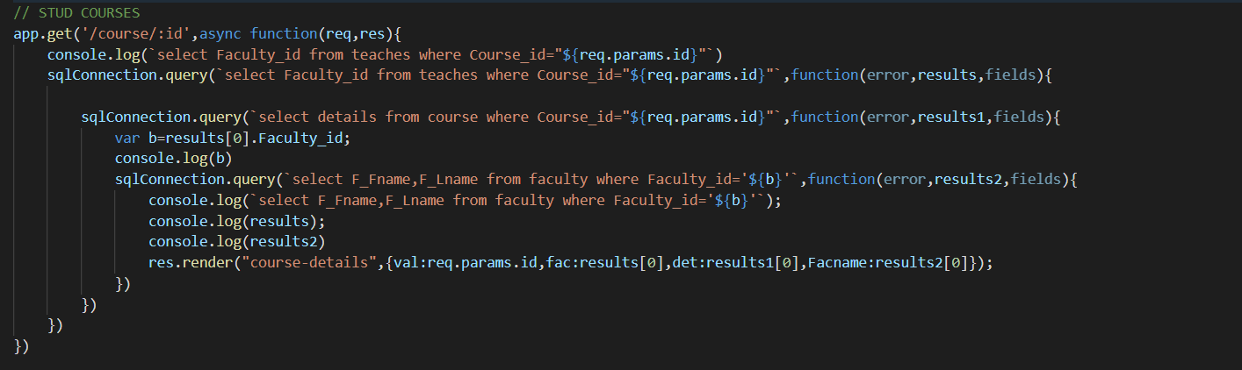

# IMG_256

# IMG_256

# Reports generated

**Overview(Number of courses,students,faculties and departments)**

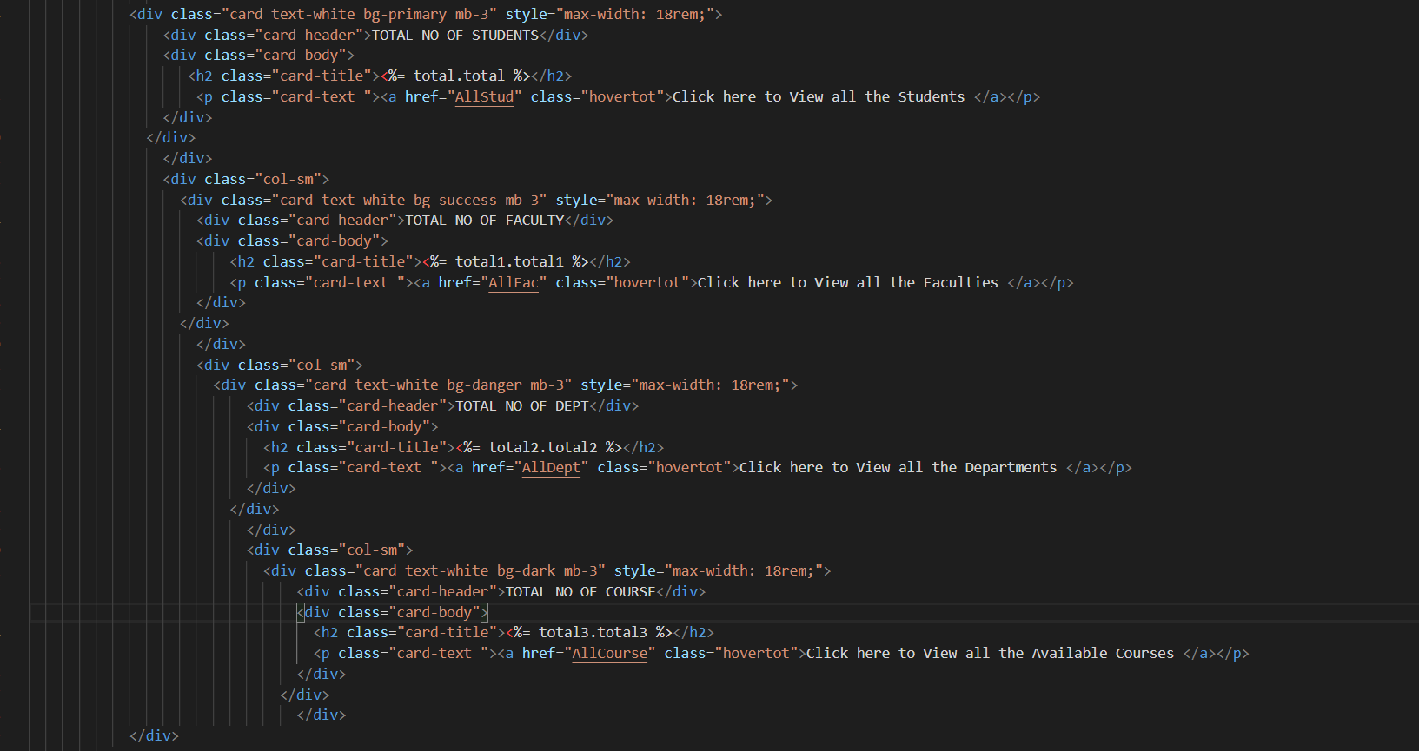

# Courses provided by each department

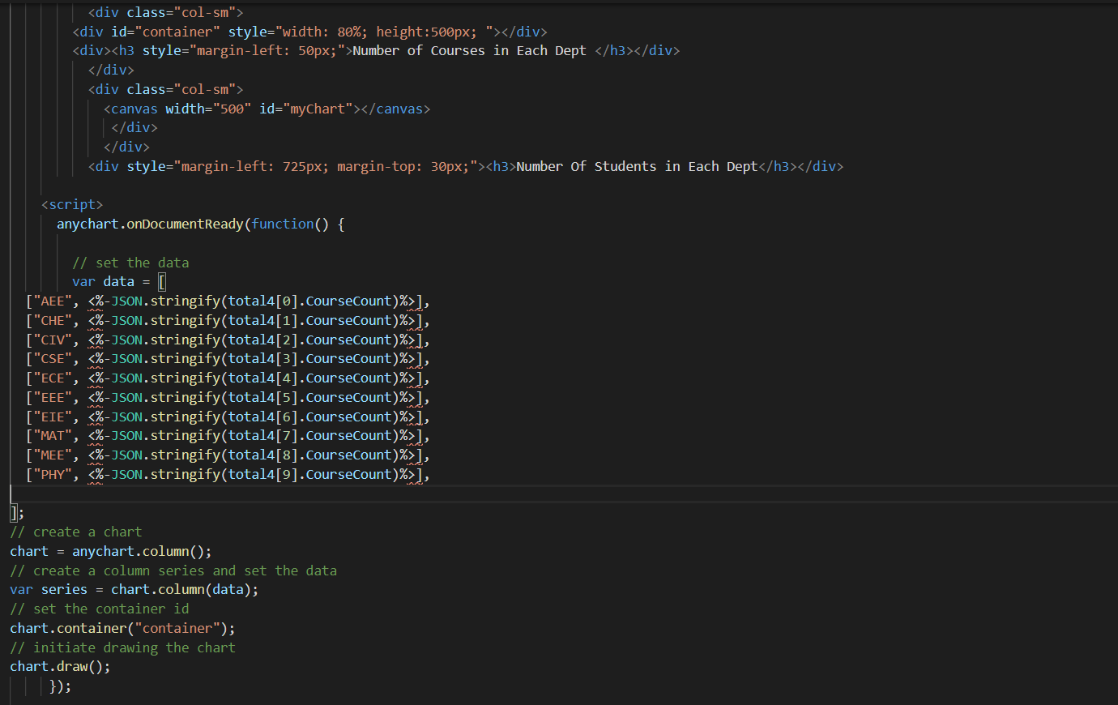

# Number of students in each department

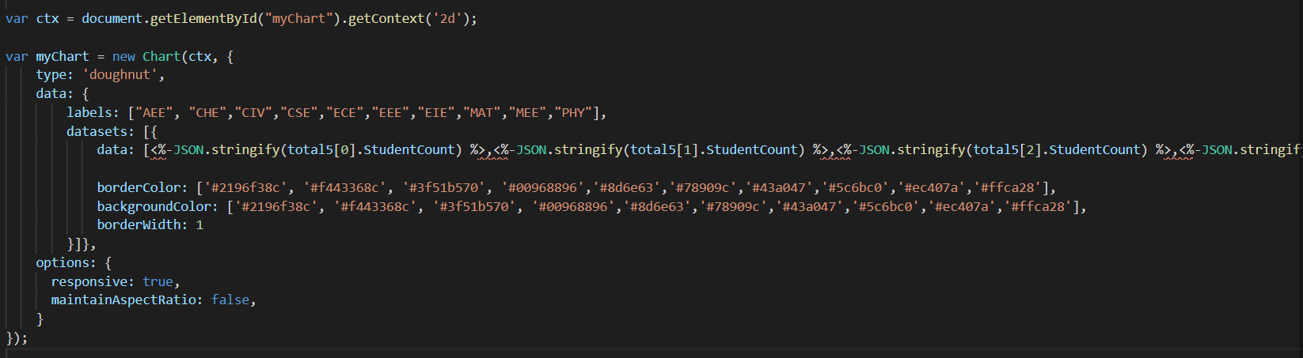

**Student performance**

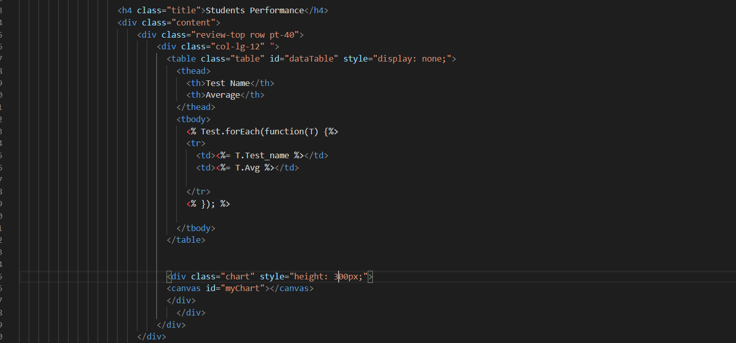

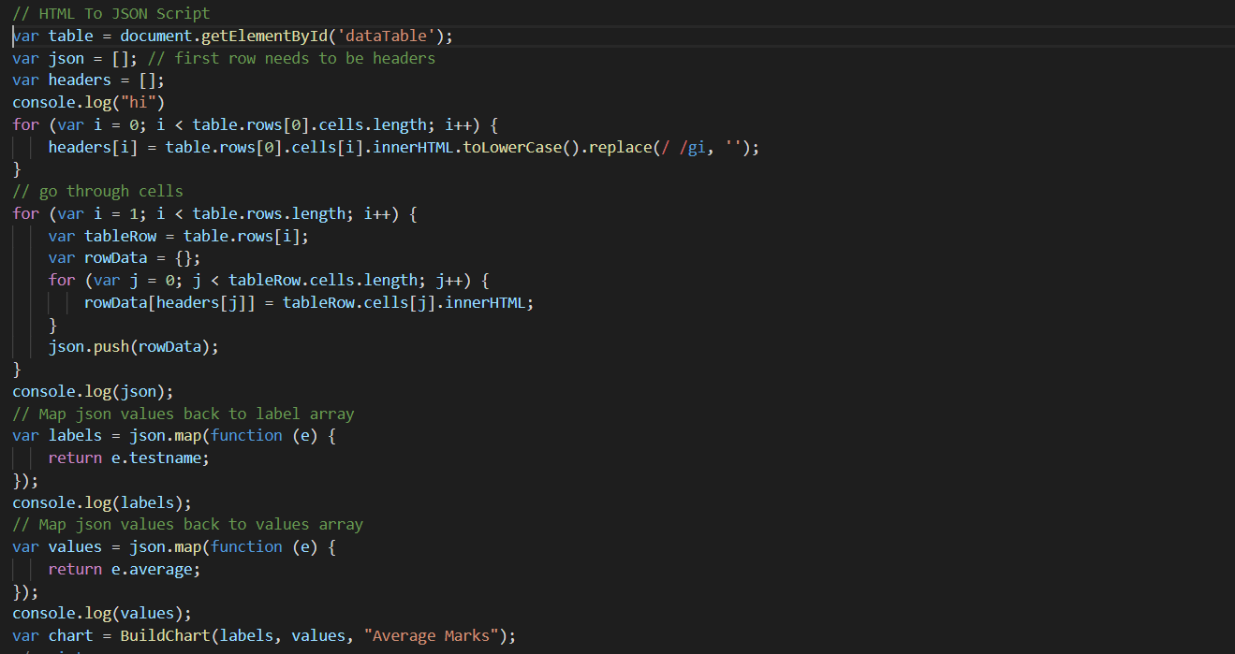

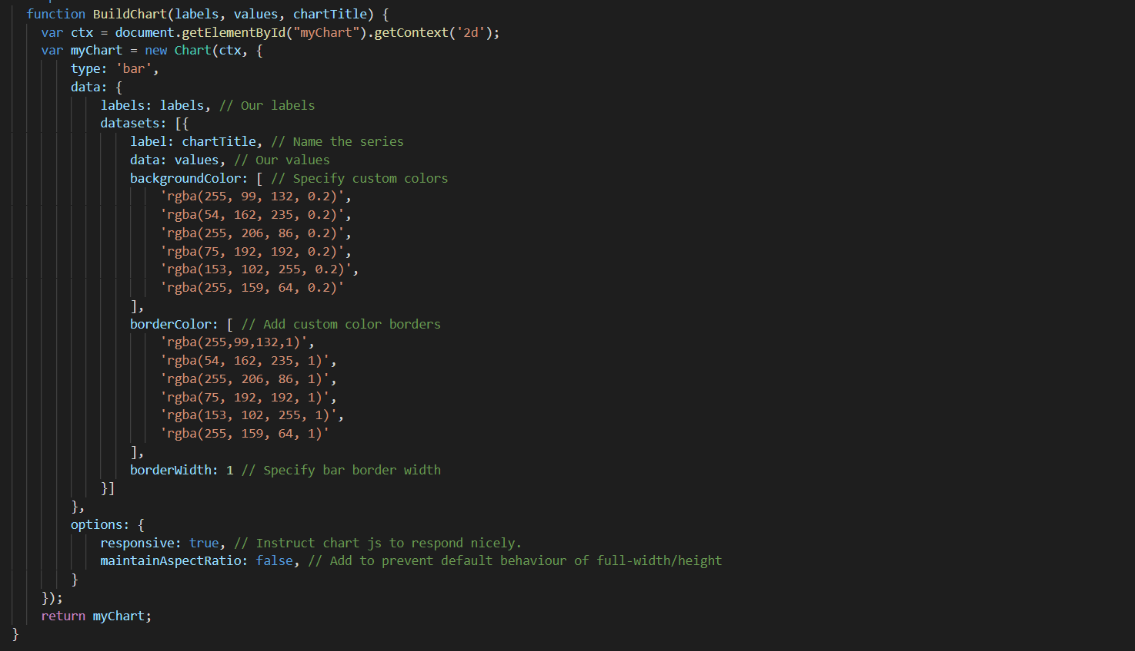

# Chapter 9 UI Screens

# Admin(Reports)

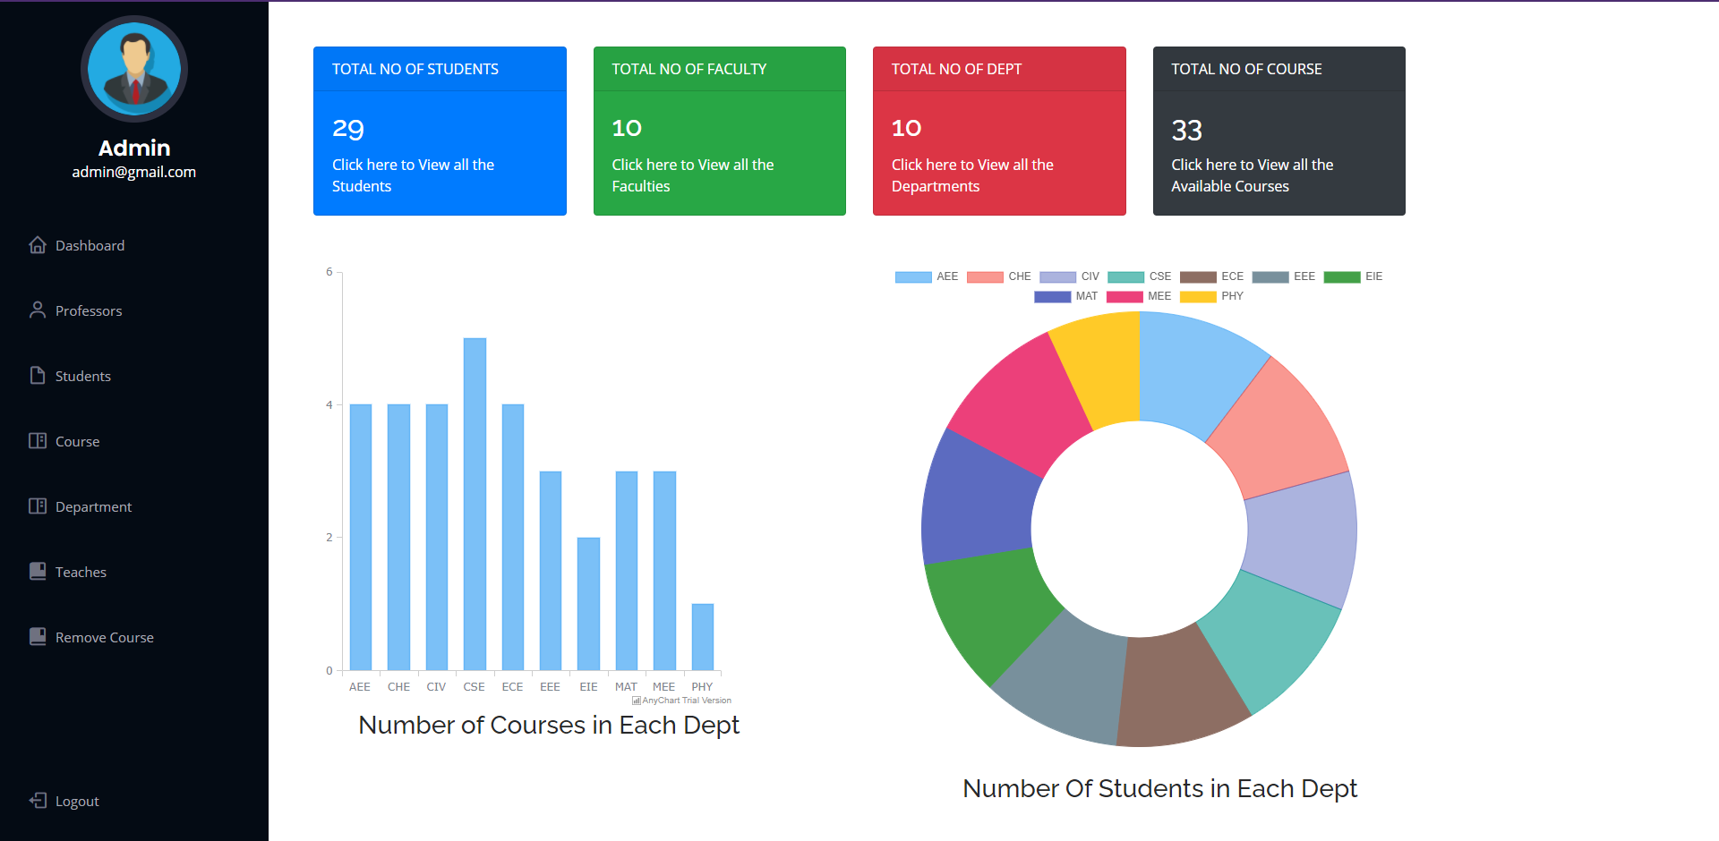

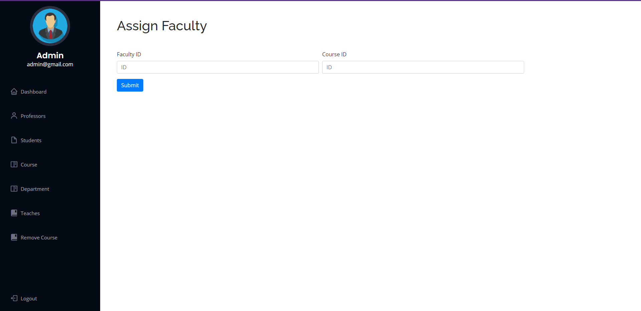

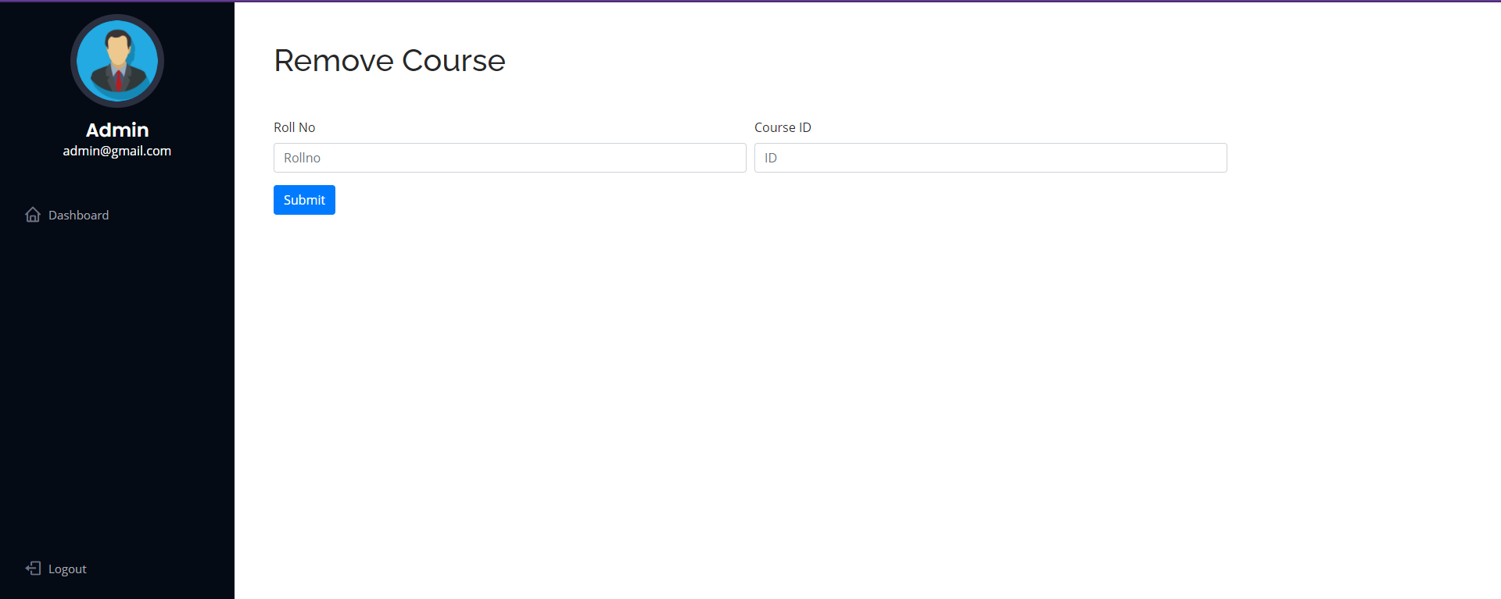

**Course Registration**

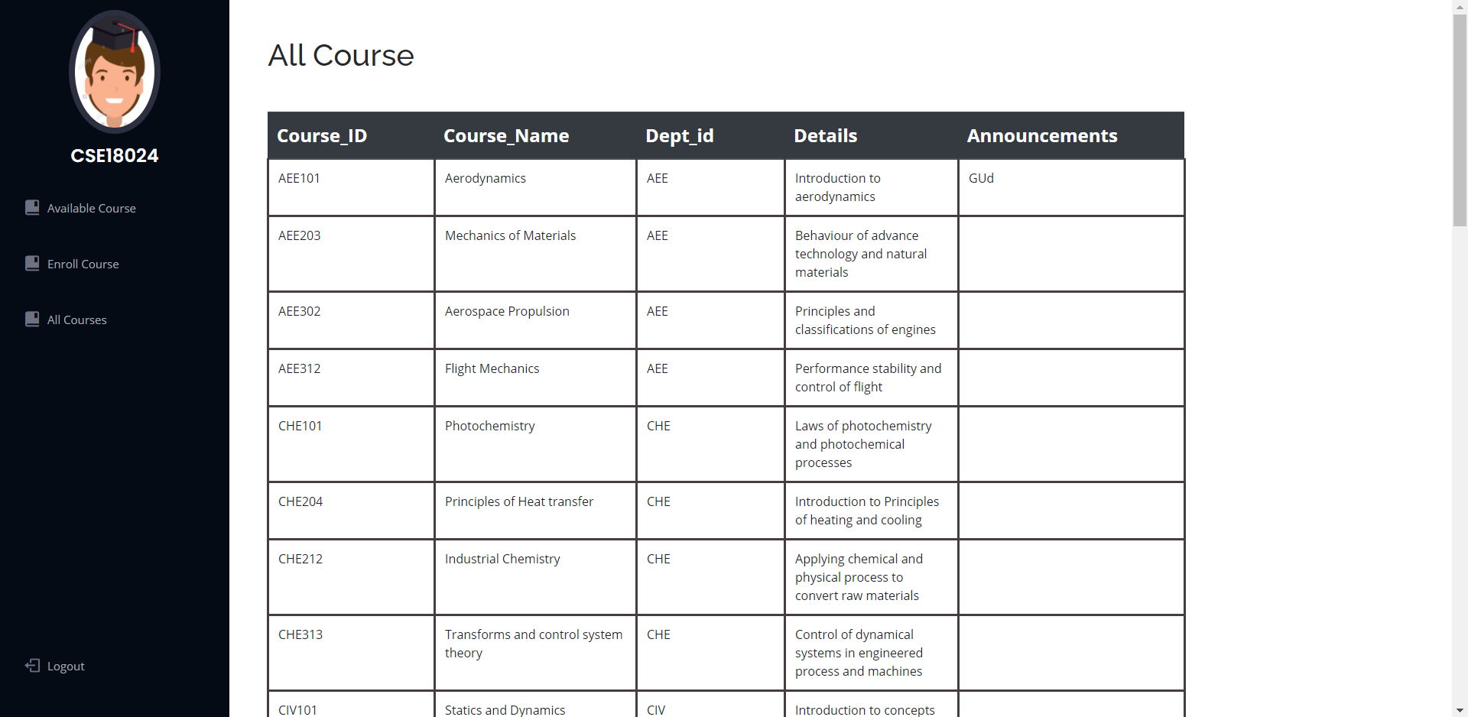

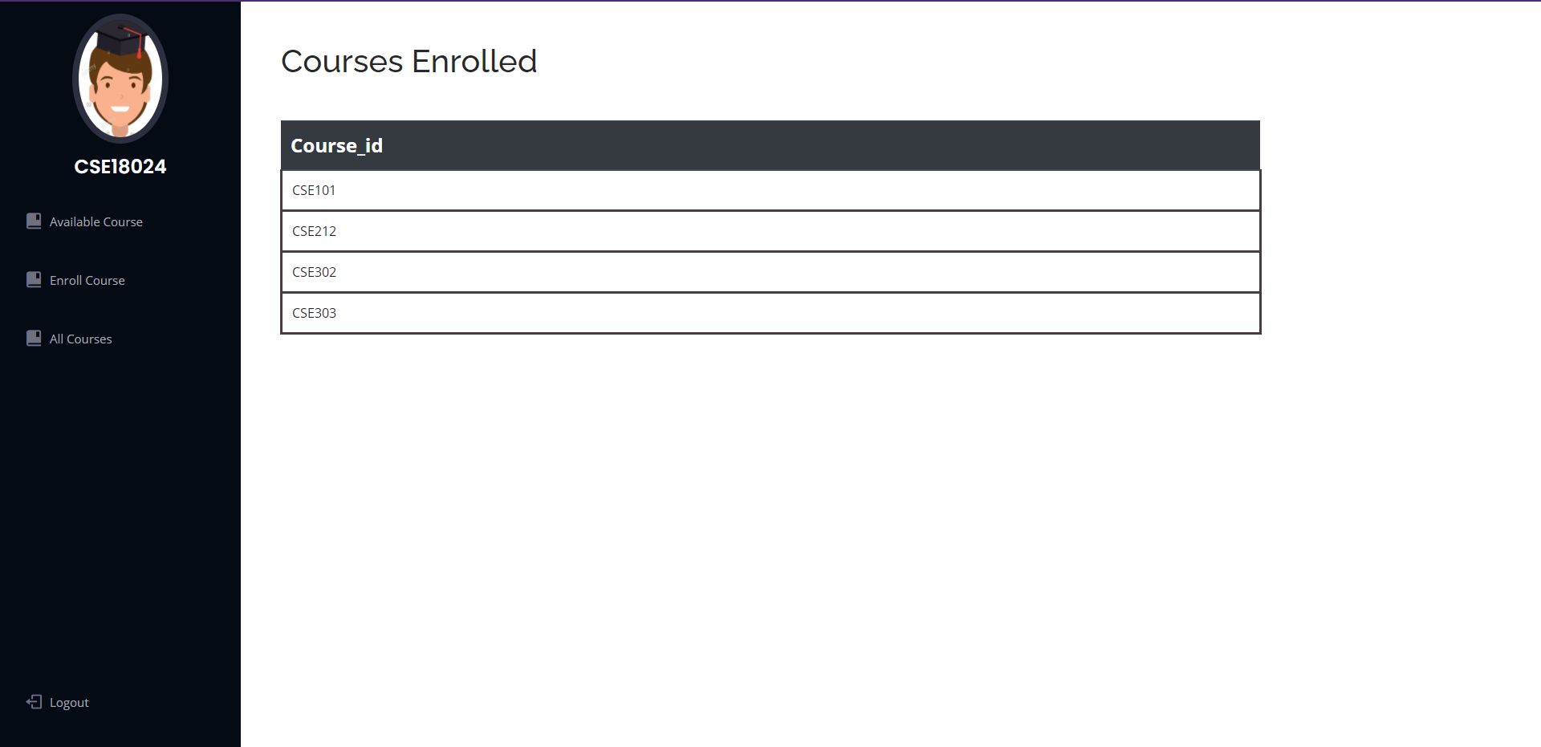

# **Student page**

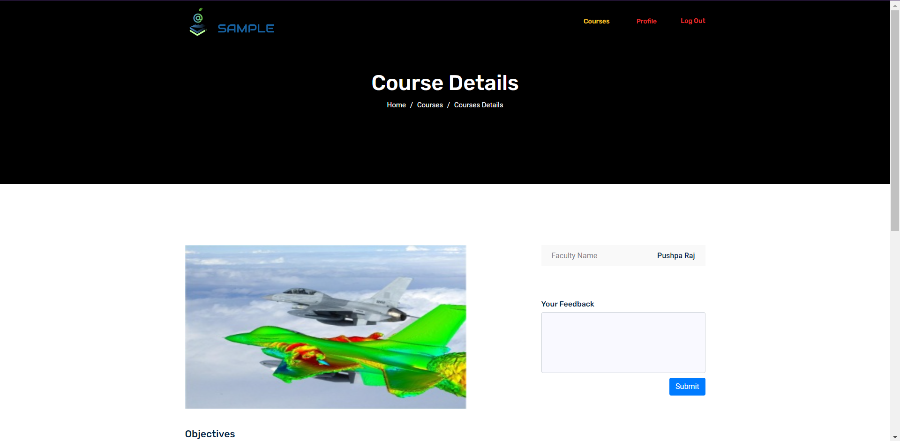

# IMG_256

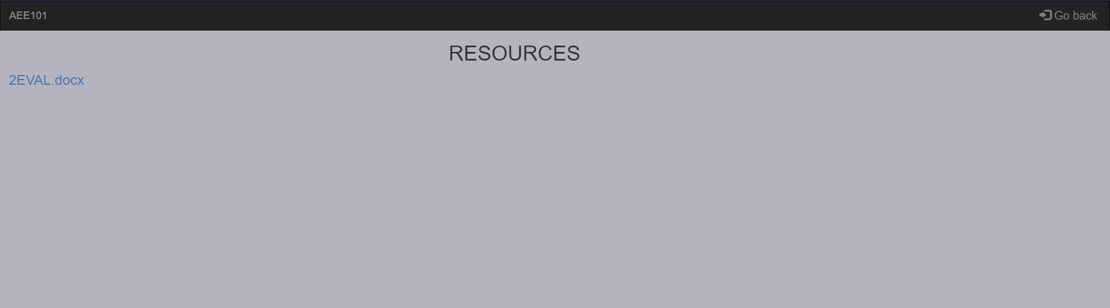

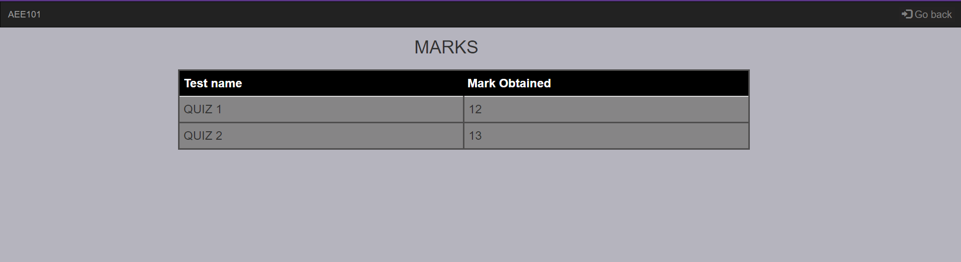

# Faculty page

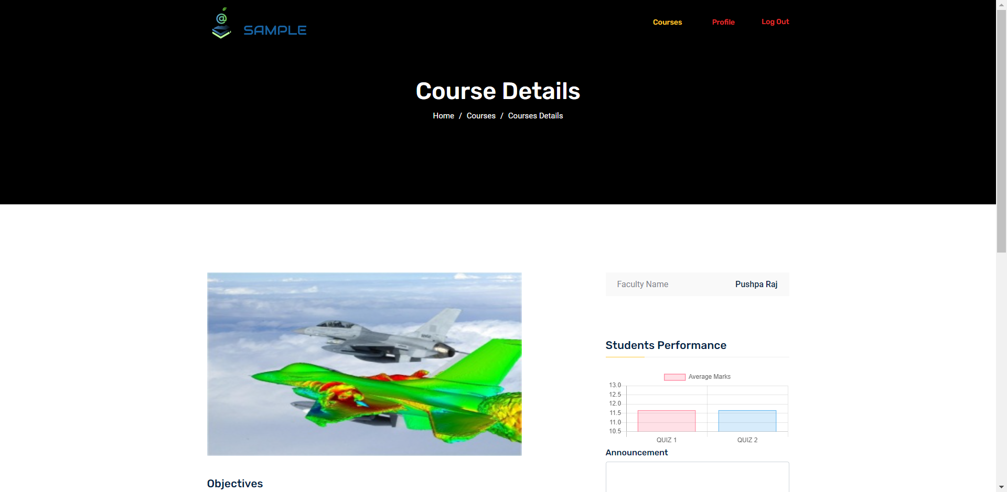

# IMG_256

# References

**Books reference:**

Abraham Silberschatz, Henry F. Korth and S. Sudarshan, Database Systems Concepts. 7th edition. New York, NY: McGraw-Hill, [2020]

**Websites reference:**

<https://getbootstrap.com/docs/4.1/getting-started/introduction/>

<http://www.ict.griffith.edu.au/~jw/normalization/ind.php>

<https://www.w3schools.com/>

<https://www.chartjs.org/docs/>

<https://www.anychart.com/products/anychart/docs/>

https://css-tricks.com/the-many-ways-of-getting-data-into-charts/